**Software/Hardware Design Description**

**for**

**Autonomous Train Control System**

**(Version 1)**

**Prepared by Orange Juice and the Cowboy Hats**

**Record of Changes**

| **Change Date** | **Version** | **Description of Change** | **Author** | **Comments** |
| --- | --- | --- | --- | --- |
| **01/12/24** | **1.0** | **Initial document creation** | **OJ&CH** | **Initial template** |
| **03/07/24** | **1.1** | **Added changes according to feedback received from Iteration 2** | **OJ&CH** | **Document ready for Work Package 2** |

Table of Contents

**1.Overview 5**

1.1 Scope 5

1.2 Purpose 5

1.3 Intended Audience 5

1.4 Conformance 5

**2. Definitions 5**

**3. Conceptual Model for Software Designs Descriptions 7**

3.1 Software Design in Context 7

3.2 Software Design Description Within the Lifecycle 7

**4. Design Description Information Content 7**

4.1 Introduction 7

4.2 SDD Identification 8

4.3 Design Stakeholders and Their Concerns 8

4.4 Design Views 8

4.5 Design Viewpoints 8

4.6 Design Languages 9

**5. Design Viewpoints 9**

5.1 Introduction 9

5.2 Context Viewpoint 9

5.2.1 CTC 9

5.2.1.1 CTC - Use Case Descriptions 9

5.2.1.2 CTC - Use Case Diagram 13

5.2.2 Wayside Controller (Software) 13

5.2.2.1 Wayside Controller (Software) - Use Case Descriptions 13

5.2.2.2 Wayside Controller (Software) - Use Case Diagram 18

5.2.3 Wayside Controller (Hardware) 18

5.2.3.1 Wayside Controller (Hardware) - Use Case Descriptions 18

5.2.3.2 Wayside Controller (Hardware) - Use Case Diagram 25

5.2.4 Track Model 25

5.2.4.1 Track Model - Use Case descriptions 25

5.2.4.2 Track Model Use Case Diagram 29

5.2.5 Train Model 30

5.2.5.1 Train Model - Use Case Descriptions 30

5.2.5.2 Train Model - Use Case Diagram 34

5.2.6 Train Controller 34

5.2.6.1 Train Controller - Use Case Descriptions 34

5.2.6.2 Train Controller - Use Case Diagram 40

5.3 Composition Viewpoint 41

5.4 Logical Viewpoint 42

5.4.1 CTC - Class Diagram 42

5.4.2 Wayside Controller - Class Diagram 43

5.4.2.1 Software 43

5.4.2.1 Hardware 44

5.4.3 Track Model - Class Diagram 44

5.4.4 Train Model - Class Diagram 45

5.4.5 Train Controller - Class Diagram 46

5.5 Dependency Viewpoint 48

5.5.1 CTC 48

5.5.2 Wayside Controller (Software & Hardware) 49

5.5.3 Track Model 50

5.5.4 Train Model 50

5.5.5 Train Controller 51

5.6 Patterns Use Viewpoint 52

5.6.1 Block (Class) 52

5.7 Interface Viewpoint 53

5.7.1 CTC - UI 53

5.7.2 Wayside Controller - UI 54

5.7.2.1 Software 54

5.7.2.2 Hardware 54

5.7.3 Track Model - UI 56

5.7.4 Train Model - UI 57

5.7.5 Train Controller - UI 58

5.8 Interaction Viewpoint 59

5.8.1 CTC 60

5.8.2 Wayside Controller 62

5.8.2.1 Software 62

5.8.3.2 Hardware 65

5.8.3 Track Model 67

5.8.4 Train Model 70

5.8.5 Train Controller 75

5.9 State Dynamics Viewpoint 81

5.9.1 CTC 81

5.9.2 Wayside Controller 82

5.9.2.1 Software 82

5.9.2.1 Hardware 82

5.9.3 Track Model 83

5.9.4 Train Model 83

5.9.5 Train Controller 84

5.10 Resource Viewpoint 85

# 

# **1.Overview**

## 1.1 Scope

This document will cover the overall architecture of the train control system. This will include the defined modules of the system and their communication with each other. It will define the key concepts used in the system such as route, authority, and simulation timing among others. These concepts will be defined, and the design of each of these in the system shall be discussed. This document will include diagrams such as use case, class, sequence, and deployment diagrams, that relate to the software and the overall design of the system. These diagrams will assist in the discussion of the software decisions that were made when designing the system.

## 1.2 Purpose

This document will serve as the Software/Hardware design description for the train control system. The purpose of this document is to specify the design choices of the system. It will specify design information and address design concerns of the system. The main goal of collecting this information is to present the design choices to the stakeholders of the system.

## 1.3 Intended Audience

This document is crafted to be reviewed by the instructor and TA of this course. In a real life situation the intended audience would be the stakeholders, who are likely the ones funding and commissioning the project.

## 1.4 Conformance

Our product will meet all major requirements, with the exception of the initially provided track layout as it is physically impossible.

# **2. Definitions**

| **Term** | **Definition** |
| --- | --- |
| Authority | Distance in meters a train has the clearance to travel |
| CSV file | Comma Separated Value File |
| CTC | Centralized Traffic Control |
| Dispatcher | User who specifies when and where trains are supposed to travel in the system |
| GUI | Graphical User Interface |
| KI | Integral Gain |
| KP | Proportional Gain |
| Murphey | Entity/User of the system that causes failures by breaking the track and train |
| PLC | Programmable Logic Controllers |
| Programmer | User who creates and uploads the PLC files to the wayside controllers |
| PyQt5 | A python library for creating GUIs utilizing the Qt Company’s GUI toolkit |
| Route | The specific path a train takes as it travels along the track |
| SDD | Software/Hardware Design Description |
| SRS | Software Requirements Specifications |
| System Architecture | Encompassing term for how our TCS is divided into modules, and the communications between those modules and the users of the system. |
| TCS | Train Control System |
| Simulation Timing | How the system is synchronized in our simulation while simulating real world conditions of delay for certain events. |
| Train Controller | Vital component that is responsible for the behavior of each train |
| Train Engineer | User who determines and provides KI and KP for the Train Controller |
| UI | User Interface |
| User | A person who will interact with the system |
| Vital | Responsible for the safety of the system |
| Wayside Controller | Synonymous with track controller. A vital component responsible for the track behavior and ensuring trains do not collide. |
| Wayside Distribution | The configuration of wayside controllers and their area of coverage over the track. Will cover the whole track. |

# **3. Conceptual Model for Software Designs Descriptions**

## 3.1 Software Design in Context

The Train Control System (TCS) is developed using a simple yet effective approach, focusing on modular and object-oriented design principles. The main software application in this innovative system is Python, chosen for its adaptability and strength, together with the dynamic duo of PyQt5 for graphical user interface development and Visual Studio Code (VS code) as the editing application.

The main goal of the TCS is to forge a system that stands as a beacon of accuracy and responsiveness. Integrating the system with Raspberry Pi allows for the creation of a key where the digital functionality of the user interface (UI) and physical dependability of the train are perfectly aligned. The system is designed to run on Windows 10, positioning it as an important component of train control operations where efficiency and precision are important, making sure that different modules integrate seamlessly with user interactions and the platform’s capabilities to handle tasks.

## 3.2 Software Design Description Within the Lifecycle

The lifecycle of the project is from January (2024) to April (2024)

# **4. Design Description Information Content**

## 4.1 Introduction

This section delves into how our team, the Orange Juice and the Cowboy Hats will be designing and implementing the train system requested by the client. The upcoming sections will discuss the identification of this SDD, the esteemed design stakeholders and their concerns, the design views and viewpoints along with the design languages implemented into this project.

## 4.2 SDD Identification

The train system is set to be released in the middle of April 2024. All valid and appropriate tests will be conducted before release. As of March 2024, the project is at its design review stage and the authorship of this document belongs to the team Orange Juice and the Cowboy hats and its members, namely, Abigail Magistro, Alex Smith, Lillian Jones, Anh Nguyen, Tanvi Verma, Lauren Gilfillan and Chad Collina.

## 4.3 Design Stakeholders and Their Concerns

The stakeholders are those invested in the development of the Train Control System (TCS). This consists of a small development team from Pittsburgh, PA. The main concerns of said team are system safety, maintainability, low development cost, and high-quality design.

## 4.4 Design Views

The Design View section of the Software Design Document (SDD) is a critical component aimed at addressing and resolving specific design concerns related to the software project. This section enables design stakeholders, including architects, developers, and project managers, to delve into the intricacies of the design from various perspectives, ensuring a comprehensive understanding and approach to fulfilling the project's requirements. To enhance understanding and provide a clear visualization of these design views, the SDD will incorporate Unified Modeling Language (UML) diagrams in subsequent sections. These diagrams will serve as visual aids, explaining the complex relationships and structures within the system's architecture between all modules.

## 4.5 Design Viewpoints

* Context Viewpoint: The context viewpoint includes the use case descriptions and use case diagrams for each module. It is delineated by considering actors, such as users and other stakeholders, who engage with the design subject and its associated stakeholders.
* Composition Viewpoint: The composition viewpoint includes the deployment diagram. This perspective explains the structural arrangement of the design subject and its integration with other modules.
* Logical Viewpoint: The logical viewpoint includes the class diagrams. Its objective is to expound upon both existing and designed types, delineating their implementations as classes and interfaces alongside their structural, static relationships.
* Dependency Viewpoint: The dependency viewpoint includes both the overarching architecture and the architecture of individual modules. It defines the relationships governing the interconnection and access among other modules.
* Patterns Use Viewpoint: The pattern use viewpoint delves into the block class, elucidating its design concept, abstract role, and connectors.
* Interface Viewpoint: The interface viewpoint encompasses the implementation of module UIs and hardware components. It serves as a guide for designers, programmers, and testers, offering insights into the correct utilization of services provided by a design subject.
* Interaction Viewpoint: The interaction viewpoint houses the sequence diagrams, which outline strategies for entity interaction, detailing the timing and level of actions. Regarding the State Dynamic Viewpoint, it addresses the integration of modules with each other, explaining the manner in which they will interact and operate collectively.
* Resource Viewpoint: The resource viewpoint serves to model the attributes and utilization patterns of resources within the design subject.

## 4.6 Design Languages

UML is a modeling language used to visualize and design software systems. It can be used to visualize how objects, classes, and modules interact with each other. It is useful in software abstraction to show how software systems are compartmentalized efficiently and effectively.

# **5. Design Viewpoints**

## 5.1 Introduction

In this section, we will explore the different viewpoints of our design. We will examine how our users will interact with our code, how our code will interact with the user, and how our code will interact with other modules. Furthermore, we will examine the different resources and deployments that will be involved in our software implementation.

## 5.2 Context Viewpoint

### 5.2.1 CTC

#### 5.2.1.1 CTC - Use Case Descriptions

| **Upload a Schedule (Automatic)** | |
| --- | --- |
| Actors | Dispatcher |
| Description | * Dispatcher uploads the excel .csv file with the schedule * Schedule of trains and their departure/arrival times is saved to the system |
| Data | Inputs: Schedule file -.csv  Outputs: none |
| Stimulus | Dispatcher chooses a schedule file to upload |
| Response | System parses and saves the schedule data, and dispatches the trains based on that information |
| Comments/  Exceptions | * If the uploaded schedule is incorrect/does not have all the necessary information, the system will prompt the dispatcher to correct the errors. * If multiple trains are scheduled to leave the yard at the same time, the system will warn the user of the conflict. If the error is not corrected, the system will stagger the dispatching of trains for safety * If multiple trains are scheduled to arrive at a station at the same time, the system will warn the user of the conflict. |

| **Dispatch a Train (Manual)** | |
| --- | --- |
| Actors | Dispatcher |
| Description | * Dispatcher names the train * Dispatcher selects a destination * Dispatcher selects arrival time for train to reach destination * Departure time for train is calculated for the system * The train is dispatched at the departure time |
| Data | Inputs: Train ID - str, Destination - str, arrival time -str  Outputs: none |
| Stimulus | Dispatcher enters information and indicates the train should be added to the schedule |
| Response | System will take the information about the train and add it to the schedule, the train will be dispatched at the correct time. |
| Comments/  Exceptions | * If the train is scheduled to leave the yard at the same time as a train already on the schedule, the system will warn the user of the conflict. If the error is not corrected, the system will stagger the dispatching of trains for safety * If the train is scheduled to arrive at a station at the same time as a train already on the schedule, the system will warn the user of the conflict. |

| **Display Block Occupancy Information** | |
| --- | --- |
| Actors | Wayside Controller |
| Description | * As the block occupancies change, the wayside controllers will update the CTC with the block occupancies of the Asystem * The CTC will display this information to the user, including which train is at each occupancy * The dispatcher will see this information to know |
| Data | Input: BlockOccupancies - list[str] |
| Stimulus | Wayside Controllers update the CTC with a new list of occupied blocks, which will update as trains move |
| Response | BlockOccupancy list will be displayed on UI |
| Comments/  Exceptions | * If there is a block occupancy where there shouldn’t be a train, the system will indicate that there is an issue with that block |

| **Close a Block for Maintenance** | |
| --- | --- |
| Actors | Dispatcher |
| Description | * Dispatcher sets the system to manual mode * Dispatcher selects the block(s) that are to be shut down * The system sends which blocks are closed to the wayside controllers |
| Data | Inputs: BlockID - str  Output: BlockClosures - list[str] |
| Stimulus | Dispatcher selects the block(s) to be shut down and indicates the information should be added to the system |
| Response | The system takes the current list of blocks that are closed to the wayside controllers |
| Comments/  Exceptions | none |

| **Set a Switch Position in Maintenance** | |
| --- | --- |
| Actors | Dispatcher |
| Description | * Dispatcher sets the system to manual mode * Dispatcher selects the switch that they want to set the position of * Dispatcher indicates what position the switch should be in * The system send the switch position information to the wayside controllers |
| Data | Inputs: SwitchID - str, SwitchPosition - str Outputs: SwitchPositionInfo - list[str] |
| Stimulus | Dispatcher selects the switch and what position it should be in and indicates the information should be added to the system |
| Response | The switch position of switches under maintenance will be sent to the wayside controllers |
| Comments/  Exceptions | none |

| **Display Throughput Information** | |
| --- | --- |
| Actors | Track Model |
| Description | * Every hour, the track model sends the CTC the ticket sales from every station in the system * The CTC will use the ticket sales information to display the throughput of each line of the track, in sales/hour * The dispatcher will then be able to determine if more trains need dispatched |
| Data | Inputs: TicketSale - list[int] Outputs: ThroughputGraph - .png image |
| Stimulus | The clock indicated that an hour has passed and the track model send the ticket sales for every station in the system |
| Response | The CTC will display the throughput of each line on the track, in sales/hour |
| Comments/  Exceptions | none |

#### 5.2.1.2 CTC - Use Case Diagram

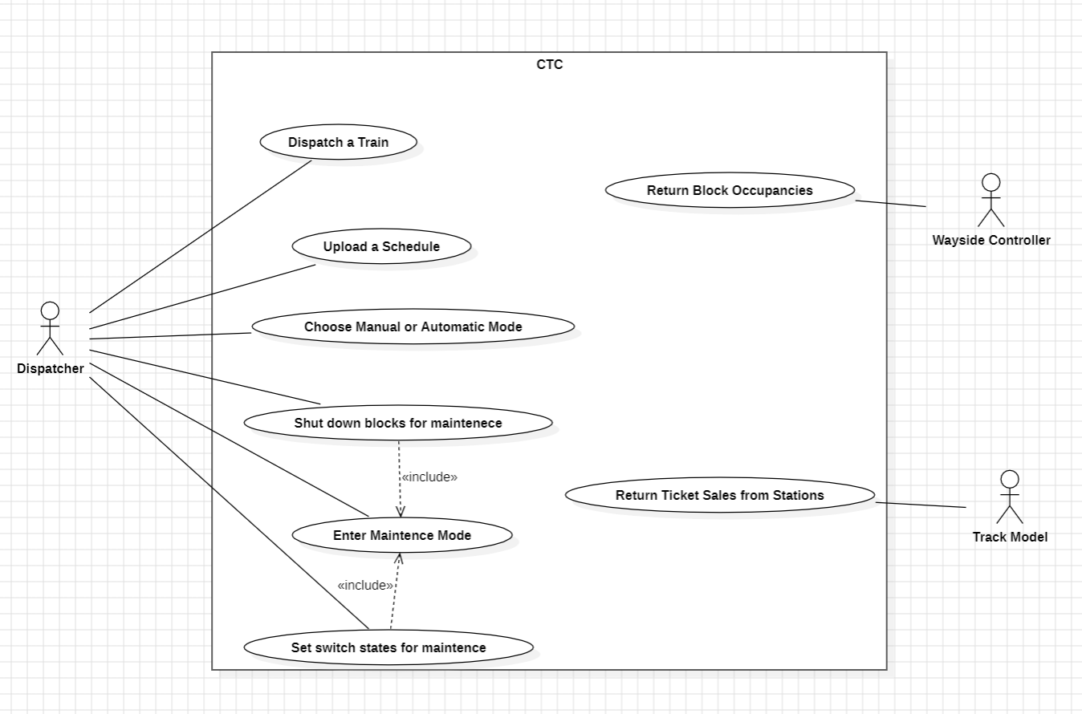

### 5.2.2 Wayside Controller (Software)

#### 5.2.2.1 Wayside Controller (Software) - Use Case Descriptions

| **Upload a PLC File** | |
| --- | --- |
| Actors | Programmer |
| Description | * Programmer uploads a PLC file that will be used to run automatic mode * Automatic behavior of switches and lights set by occupancies |
| Data | Inputs: PLC text file  Outputs: none |
| Stimulus | Programmer chooses a PLC file to upload |
| Response | The PLC file is parsed by the parser class and prepped for when automatic mode is set. |
| Comments/  Exceptions | * The PLC behavior has no effect on manual mode |

| **Enter Automatic Mode** | |
| --- | --- |
| Actors | Programmer |
| Description | * Programmer changes the mode from Manual to Automatic once the PLC file is uploaded to the wayside. |
| Data | Inputs: None  Outputs: Light states (bool) and Switch states (bool) |
| Stimulus | Programmer clicks the change mode button. |
| Response | Block occupancies will be reacted to by proper changing of switches and lights. |
| Comments/  Exceptions | * Automatic mode can only be set when a PLC file is uploaded. |

| **Select a Block to Edit** | |
| --- | --- |
| Actors | Programmer |
| Description | * Programmer selects a block from the dropdown menu to be viewed or edited. |
| Data | Inputs: none  Outputs: Block (object) |
| Stimulus | A block on a dropdown menu is selected. |
| Response | The selected block is pulled from the array. Its attributes (lights,crossings, and switches) and the states of these attributes are shown. |
| Comments/  Exceptions | * Only blocks that contain a light, crossing, or switch are shown as options on the dropdown menu. |

| **Enter Manual Mode** | |
| --- | --- |
| Actors | Programmer |
| Description | * Programmer changes the mode to Manual. |
| Data | Inputs: none  Outputs: none |
| Stimulus | A button to change the mode from Automatic is clicked. |
| Response | Lights, crossings, and switches can now be manually toggled. |
| Comments/  Exceptions | * Manual mode is the default mode. * Accidents can occur in Manual mode. |

| **Change Light State** | |
| --- | --- |
| Actors | Programmer |
| Description | * Programmer toggles the state of a light. |
| Data | Inputs: greenButtonPushed (bool) and redButtonPushed (bool)  Outputs: lightState (bool) |
| Stimulus | Green button is pushed to toggle from red or red button is pushed to toggle from green. |
| Response | The opposite state is now set, shown, and sent. If green is pushed, the light turns from red to green. If red is pushed, the light turns from green to red. |
| Comments/  Exceptions | * Only the green or the red button will be active at one time. * In Manual mode, these can be toggled. * In Automatic mode, the buttons will give a visual indication of the block states but will not be able to be clicked. * Red is the default for all lights |

| **Change Crossing State** | |
| --- | --- |
| Actors | Programmer |
| Description | * Programmer toggles the state of a crossing. |
| Data | Inputs: upButtonPushed (bool) and downButtonPushed (bool)  Outputs: crossingState (bool) |
| Stimulus | Up button is pushed to toggle from down or down button is pushed to toggle from up. |
| Response | The opposite state is now set, shown, and sent. If up is pushed, the crossing switches from down to up. If down is pushed, the crossing switches from up to down. |
| Comments/  Exceptions | * Only the up or the down button will be active at one time. * In Manual mode, these can be toggled. * In Automatic mode, the buttons will give a visual indication of the block states but will not be able to be clicked. * Up is the default state for all crossings. |

| **Change Switch State** | |
| --- | --- |
| Actors | Programmer |
| Description | * Programmer toggles the state of a switch. |
| Data | Inputs: switchButtonPushed (bool)  Outputs: switchState (bool) |
| Stimulus | Switch button is clicked. |
| Response | Switch will be changed to the opposite direction. If it is directed left it will now be directed right. If it is directed right, it will now be directed left. |
| Comments/  Exceptions | * In Manual mode, these can be toggled. * In Automatic mode, text above the button will give a visual indication of the block state but will not be able to be clicked. * Left is the default state for all switches. |

| **Send Speed** | |
| --- | --- |
| Actors | CTC Office, Track Model |
| Description | * CTC Office sends initial suggested speed to wayside controller. Wayside Controller then sends the commanded speed to Track Model. |
| Data | Inputs: suggestedSpeed (int)  Outputs: commandedSpeed (int) |
| Stimulus | Speed is originally sent from CTC Office. |
| Response | Speed is determined by the wayside. If the train does not need to stop, we pass on the speed to the Track Model. If we need to stop, we send 0 for the speed instead. |
| Comments/  Exceptions |  |

| **Send Authority** | |
| --- | --- |
| Actors | CTC Office, Track Model |
| Description | * CTC Office sends initial authority to wayside controller. Wayside controller sends final authority to Track Model. |
| Data | Inputs: authority (int)  Outputs: authority (int) |
| Stimulus | Authority is originally sent from CTC Office. |
| Response | Authority is determined by the wayside. If the train does not need to stop due to other occupancies, authority will start as distance to the desired stop and decrement value by the block lengths. If there are occupancies in the way, authority will be changed to not cause any accidents. |
| Comments/  Exceptions |  |

| **Send Block Occupancies** | |
| --- | --- |
| Actors | CTC Office,Track Model |
| Description | * Block occupancies are sent from the Track Model to the Waysides. |
| Data | Inputs: occupiedBlocks (list[Block])  Outputs: (in Automatic mode) greenButtonPushed (bool), redButtonPushed (bool), switchButtonPushed (bool), occupiedBlocks(list[Block]) to CTC |
| Stimulus | Track Model sends occupied block signals. |
| Response | Wayside controllers receive the blocks. If Automatic Mode is active, light and switch blocks are automatically determined by the PLC logic. Wayside then sends the occupied blocks to CTC. |
| Comments/  Exceptions |  |

#### 5.2.2.2 Wayside Controller (Software) - Use Case Diagram

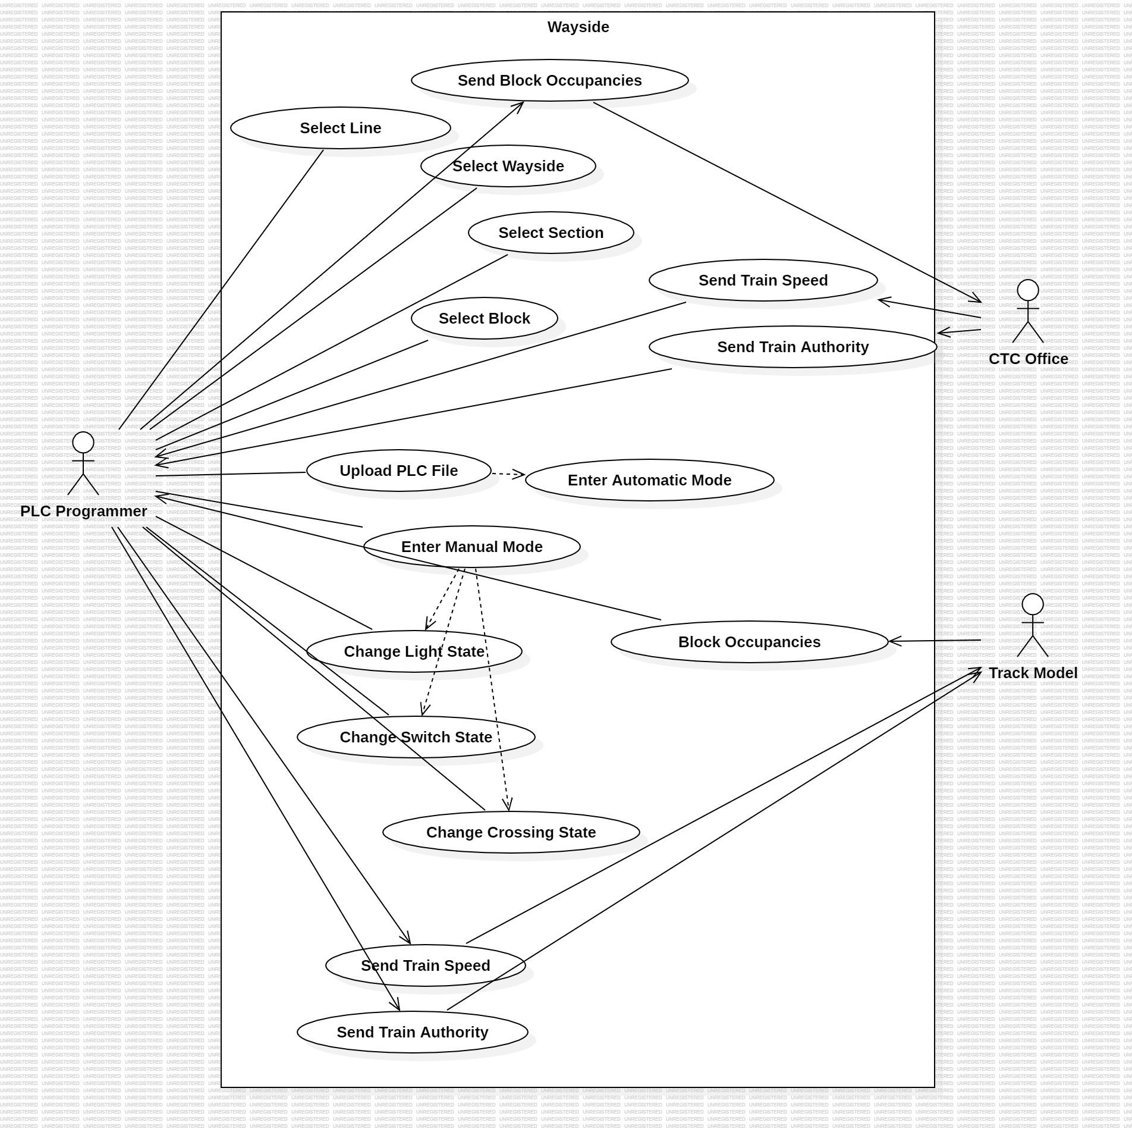

### 5.2.3 Wayside Controller (Hardware)

#### 5.2.3.1 Wayside Controller (Hardware) - Use Case Descriptions

| **Upload PLC File** | |
| --- | --- |
| Actors | PLC Programmer |
| Description | * Programmer uploads a PLC file that will be used to run system in automatic operation * Automatic behavior of system switches, lights, and crossings is determined by block occupancies |
| Data | Inputs: PLC file  Outputs: N/A |
| Stimulus | Programmer chooses a PLC file to upload. |
| Response | The PLC file is parsed by the Parser class and the system is prepped for automatic operation. |
| Comments/  Exceptions | * The PLC file data has no effect on manual or maintenance operation |

| **Enter Automatic Mode** | |
| --- | --- |
| Actors | PLC Programmer |
| Description | * System is set to automatic mode once the PLC file is uploaded to the wayside system |
| Data | Inputs: N/A  Outputs: Light states (Boolean), switch states (Boolean), crossing states (Boolean) |
| Stimulus | The PLC file is uploaded to the system. |
| Response | According to the displayed block occupancies, the data in the PLC file will change states of lights, crossings, and switches accordingly |
| Comments/  Exceptions | * Automatic mode is automatically set when a PLC file is uploaded * Accidents cannot occur under manual operation |

| **Select a Line** | |
| --- | --- |
| Actors | PLC Programmer |
| Description | * Programmer selects a line system from the available checkboxes (blue, green, or red) |
| Data | Inputs: N/A  Outputs: List[Block] |
| Stimulus | A line is selected. |
| Response | Only wayside stations that are present on that line can now be chosen. |
| Comments/  Exceptions | * To select other wayside stations on other lines, the line must be re-selected |

| **Select a Wayside** | |
| --- | --- |
| Actors | PLC Programmer |
| Description | * Programmer selects a wayside station from the drop-down menu to operate |
| Data | Inputs: N/A  Outputs: List[Block] |
| Stimulus | A wayside station on the drop-down menu is selected. |
| Response | Only block sections that are covered by that wayside station become available for selection. |
| Comments/  Exceptions | * To view other block sections, select a different wayside station |

| **Select a Section** | |
| --- | --- |
| Actors | PLC Programmer |
| Description | * Programmer selects a block section from the drop-down menu |
| Data | Inputs: N/A  Outputs: List[Block] |
| Stimulus | A block section on a drop-down menu is selected. |
| Response | Only blocks within that block section become available for selection. |
| Comments/  Exceptions | * N/A |

| **Select a Block** | |
| --- | --- |
| Actors | PLC Programmer |
| Description | * Programmer selects a block from the drop-down menu to be viewed or edited |
| Data | Inputs: N/A  Outputs: Block |
| Stimulus | A block on a drop-down menu is selected. |
| Response | The selected block is pulled from the array. The block’s attributes (lights, crossings, and switches), as well as the states of these attributes are shown. The PLC programmer is now able to manually change these states, assuming that the system is in manual operation. |
| Comments/  Exceptions | * Block states cannot be changed in automatic or maintenance operation |

| **Enter Manual Mode** | |
| --- | --- |
| Actors | PLC Programmer |
| Description | * Programmer changes the system to manual operation |
| Data | Inputs: N/A  Outputs: N/A |
| Stimulus | The manual mode check-box is checked |
| Response | Lights, crossings, and switches can now be manually toggled |
| Comments/  Exceptions | * Manual mode is the default mode, and the system can only enter automatic operation upon insertion of a PLC file * Accidents can occur under manual operation |

| **Change Light State** | |
| --- | --- |
| Actors | PLC Programmer |
| Description | * Programmer toggles the state of a light. |
| Data | Inputs: N/A  Outputs: lightState (bool) |
| Stimulus | Programmer presses the corresponding button to change the state of the light |
| Response | The state of the light is changed. If the light was green, it is now red. If the light was red, it is now green |
| Comments/  Exceptions | * In manual operation, these can be toggled, but automatic mode does not allow this * Red is the default for all lights within the system |

| **Change Crossing State** | |
| --- | --- |
| Actors | PLC Programmer |
| Description | * Programmer toggles the state of a crossing |
| Data | Inputs: N/A  Outputs: crossingState (bool) |
| Stimulus | Programmer presses the corresponding button to change the state of the crossing |
| Response | The state of the crossing is changed. If the crossing was up, it is now down. If the crossing was down, it is now up. |
| Comments/  Exceptions | * In manual operation, these can be toggled, but automatic mode does not allow this * Up is the default for all crossings within the system |

| **Change Switch State** | |
| --- | --- |
| Actors | PLC Programmer |
| Description | * Programmer toggles the state of a switch |
| Data | Inputs: N/A  Outputs: switchState (bool) |
| Stimulus | Programmer presses the corresponding button to change the state of the light |
| Response | Switch will be changed to the opposite direction. If it was directed left, it will now be directed right. If it was directed right, it will now be directed left. |
| Comments/  Exceptions | * In manual operation, these can be toggled, but automatic mode does not allow this * Left is the default for all switches within the system |

| **Send Speed** | |
| --- | --- |
| Actors | CTC Office, Track Model |
| Description | * CTC Office sends the initial suggested speed to the Wayside controller. The Wayside controller then sends the commanded speed to the Track Model |
| Data | Inputs: suggestedSpeed (int)  Outputs: commandedSpeed (int) |
| Stimulus | Speed is originally sent from CTC Office. |
| Response | Speed is determined by the Wayside controller. If the train does not need to stop, the wayside controller passes-on the speed to the Track Model without change. If the train must stop, the Wayside controller sends zero for the speed instead. |
| Comments/  Exceptions | * N/A |

| **Send Authority** | |
| --- | --- |
| Actors | CTC Office, Track Model |
| Description | * The CTC Office sends initial authority to the Wayside controller. The Wayside controller sends final authority to the Track Model. |
| Data | Inputs: authority (int)  Outputs: authority (int) |
| Stimulus | Authority is originally sent from the CTC Office. |
| Response | Authority is determined by the Wayside controller. If the train does not need to stop due to other occupancies, authority will start as distance to the desired stop and decrement value by the block lengths. If there are occupancies in the way, authority will be changed to prevent accidents. |
| Comments/  Exceptions | * N/A |

| **Send Block Occupancies** | |
| --- | --- |
| Actors | CTC Office, Track Model |
| Description | * Block occupancies are sent from the Track Model to the Wayside controller, and these occupancies are forwarded to the CTC Office |
| Data | Inputs: occupiedBlocks (Block)  Outputs: (in Automatic mode) greenButtonPushed (bool), redButtonPushed (bool), switchButtonPushed (bool) |
| Stimulus | Track Model sends occupied block signals. |
| Response | Wayside controllers receive block occupancies. If in automatic operation, light, switch, and crossing blocks are automatically determined by the PLC logic. Then, the occupancies are forwarded to the CTC office. |
| Comments/  Exceptions | * N/A |

#### 5.2.3.2 Wayside Controller (Hardware) - Use Case Diagram

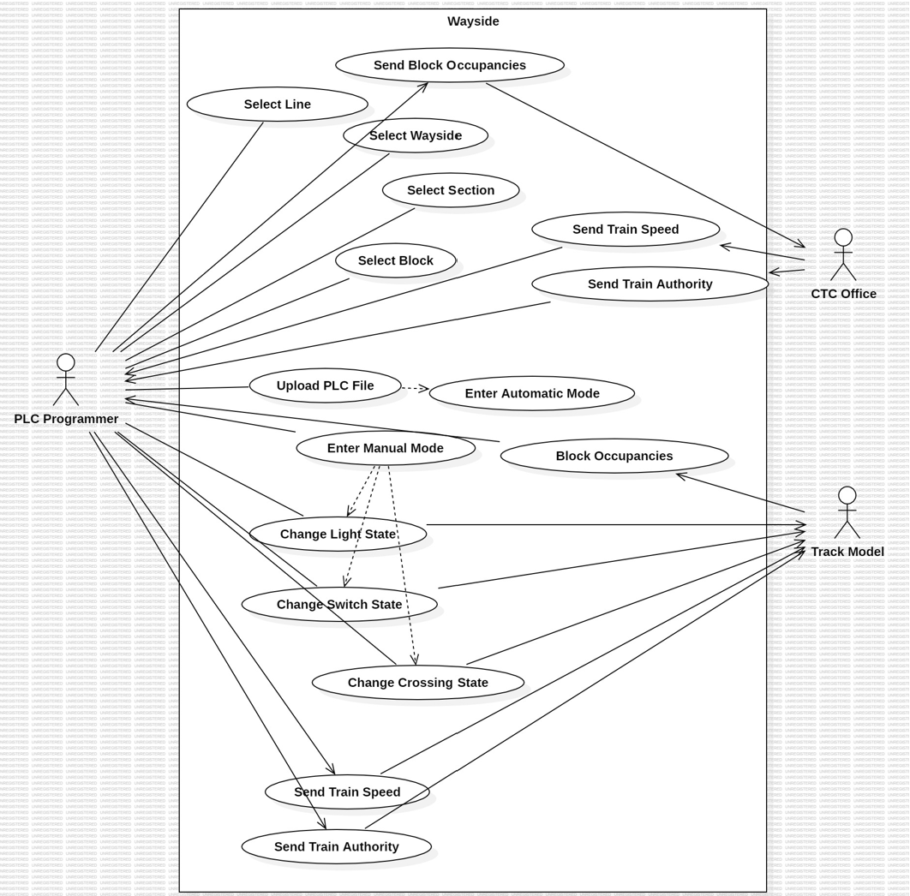

### 5.2.4 Track Model

#### 5.2.4.1 Track Model - Use Case descriptions

| **Toggle Failures** | |
| --- | --- |
| Actors | Murphy |
| Description | Murphy will initiate a failure whenever they need to. This initiating scenario includes broken rails, track circuit failures, and power failures. |
| Data | Inputs: Failure (each) - bool (per block) Outputs: Failure (each) - bool (per block) |
| Stimulus | Murphy can select a specific failure type from UI and toggles it to ON/OFF to initiate the failure. |
| Response | Once the system receives failure signals via boolean values, those signals will be sent to the Wayside Controller to be passed onto the CTC. |
| Comments/  Exceptions | N/A |

| **Uploading Track Layout** | |
| --- | --- |
| Actors | Track Builder |
| Description | The Track Builder is responsible for updating track layout by uploading the track layout data stored in CSV or Excel files. When they do so track layout data will update according to the file data. |
| Data | Inputs: Track Layout File - .csv or .xls  Outputs: Block data - str |
| Stimulus | Track Builder selects a .csv or .xls file containing the updated track layout and uploads them to the system. |
| Response | Once receiving the file, the system processes the uploaded data, integrating it into existing data and updates new block data. |
| Comments/  Exceptions | * The system needs to validate the format of the file to prevent errors during data integration. |

| **Take in Commanded Speed, Authority, Track Lights and Switch Status** | |
| --- | --- |
| Actors | Wayside Controller |
| Description | The Wayside Controller must send commanded speed, authority, and lights and switch status so that the information can be passed onto the train model and eventually be applied to the physical train. |
| Data | Inputs: Commanded speed - int (km/h), Authority - int (m), light and switch status - bool  Outputs (to train model) : Commanded speed - int (km/h), Authority - int (m)  Outputs: Lights - bool (green or red), Switch - bool (up or down) |
| Stimulus | Wayside controller inputs for commanded speed and authority for specific blocks along with light and switch status. |
| Response | Once commanded speed and authority is given, the track model will output it to the train model to be passed down to the train controller. Also, light and switch status shall be updated in the main UI. |
| Comments/  Exceptions | Real-time information of lights and switches for certain block shall be updated upon receiving the information. |

| **Sending Ticket Sales** | |
| --- | --- |
| Actors | CTC |
| Description | Every hour, the track model sends the CTC the ticket sales from every station in the system. |
| Data | Outputs: TicketSale - list[int] |
| Stimulus | The clock indicated that an hour has passed and the track model send the ticket sales for every station in the system |
| Response | Upon receiving the ticket sales data, the CTC Operator reviews the information and makes strategic decisions to adjust train schedules. |
| Comments/  Exceptions | N/A |

| **Sending Track Data to Train Model** | |
| --- | --- |
| Actors | Train Model |
| Description | Track Model will send and update train model with information such as commanded speed, authority, grade, and beacon information. |
| Data | Outputs: Commanded speed - int (km/h), Authority - int (m), grade - int (%), beacon - int (bytes) |
| Stimulus | Track Model uses commanded speed and authority from Wayside Controller and outputs it to train model. Track model will also use grade info from the Excel parser and beacon information to send to the train model. |
| Response | Upon receiving the commanded speed and authority, the train model will use them for calculation as well as sending them over to the train controller. |
| Comments/  Exceptions | N/A |

| **Sending Presence on Block to Wayside Controller** | |
| --- | --- |
| Actors | Wayside Controller |
| Description | Track Model will send block occupancy information to Wayside Controller. |
| Data | Outputs: BlockOccupancies - list[str] |
| Stimulus | Track model will use actual velocity from train model and authority along with block length from Excel parser to calculate block occupancy to be sent to Wayside Controller. |
| Response | Upon receiving the occupancy information, the Wayside controller will send information to CTC and update its system of the status of the train’s location. |
| Comments/  Exceptions | In cases where occupancy data conflicts or causes disruption in the  system, CTC will send out block maintenance. |

| **Setting Environmental Temperature** | |
| --- | --- |
| Actors | Track Model |
| Description | Track Model can set environmental temperature which toggle track heaters on if the temperature is below 35.06 degrees Fahrenheit. If the environmental temperature is above 35.06 degrees Fahrenheit, then track heaters toggles off. |
| Data | Inputs: Set environmental temp - int  Outputs: Temperature - int, Track heaters - bool |
| Stimulus | Track model will set environmental temperature. |
| Response | Upon receiving environmental temperature, track model UI will set track heaters on/off based on the threshold of 35.06 degrees Fahrenheit. |
| Comments/  Exceptions | N/A |

#### 5.2.4.2 Track Model Use Case Diagram

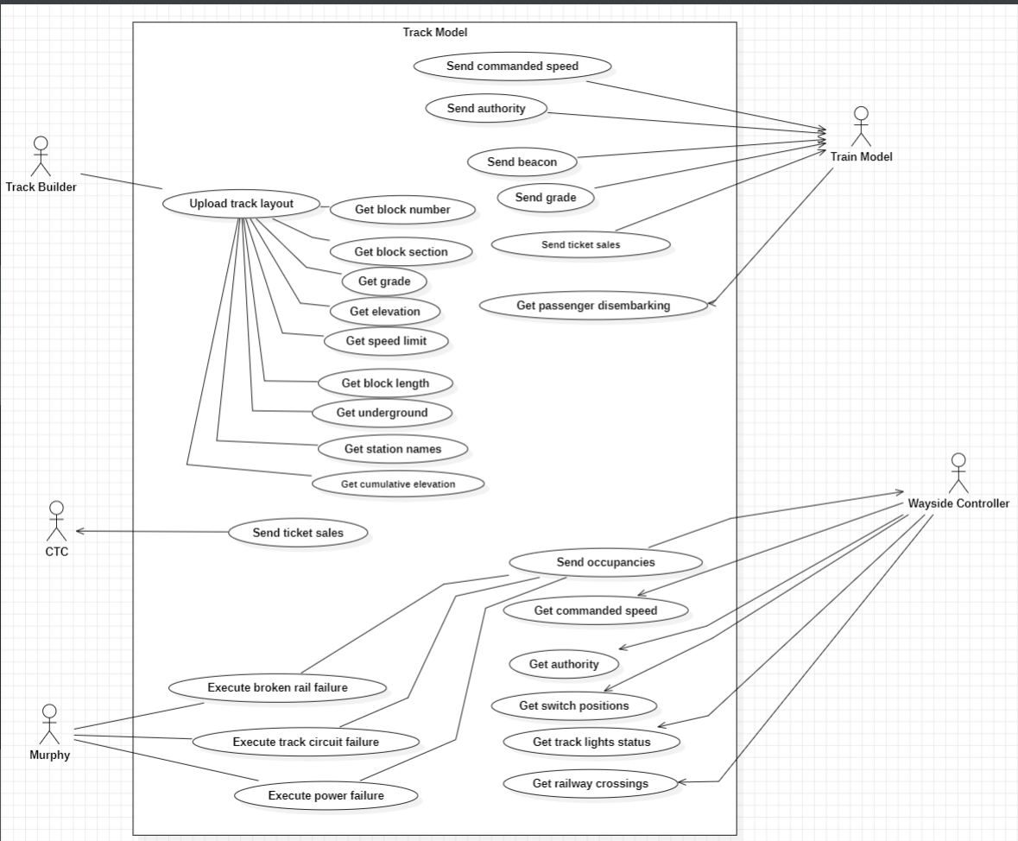

### 

### 

### 

### 5.2.5 Train Model

#### 5.2.5.1 Train Model - Use Case Descriptions

| **Change Power** | |
| --- | --- |
| Actors | Train Controller |
| Description | Train Controller sends power function to Train Model |
| Data | power-float |
| Stimulus | Train Controller emits a pyQt signal to send power function to Train Model |
| Response | Train Model does a series of calculations to calculate actual velocity and reports it back to train controller |
| Comments/  Exceptions | N/A |

| **Apply Emergency Stop** | |
| --- | --- |
| Actors | Passenger |
| Description | Passenger will hit the emergency stop button in case of an emergency causing the train to come to an immediate stop. |
| Data | Emergency Stop - bool |
| Stimulus | Passenger presses the Emergency Stop button |
| Response | Train Model passes on the information to Train Controller for quick action |
| Comments/  Exceptions | N/A |

| **Apply Murphy Failures** | |
| --- | --- |
| Actors | Murphy |
| Description | Murphy can deliver Brake Failure, Engine Failure and Signal Pickup Failure to the Train Model |
| Data | Brake_fail, engine_fail, sig_pick_fail - bool |
| Stimulus | Murphy toggles the failure switches to the ‘Enable’ position |
| Response | Train Model passes on the information to Train Controller for quick action |
| Comments/  Exceptions | N/A |

| **Send Authority** | |
| --- | --- |
| Actors | Track Model |
| Description | Track Model forwards authority to Train Model |
| Data | authority |
| Stimulus | Track Model emits a pyqt signal to forward authority to train model |
| Response | Train Model passes on authority to Train Controller |
| Comments/  Exceptions | N/A |

| **Send Beacon** | |
| --- | --- |
| Actors | Track Model |
| Description | Track Model forwards beacon to Train Model |
| Data | Beacon-128 characters |
| Stimulus | Track Model emits a pyqt signal to forward beacon to train model |
| Response | Train Model passes on beacon to Train Controller |
| Comments/  Exceptions | N/A |

| **Post Announcements** | |
| --- | --- |
| Actors | Train Controller |
| Description | Train Controller sends live announcements to train model |
| Data | announcement- str |
| Stimulus | Train Controller emits a pyqt signal to send announcements to Train Model |
| Response | Train Model displays updated announcement on its UI |
| Comments/  Exceptions | N/A |

| **Change Internal or External Lights** | |
| --- | --- |
| Actors | Train Controller |
| Description | Train Controller sends Int/Ext Light Status to Train Model |
| Data | Int_lights, ext_lights |
| Stimulus | Train Controller emits a pyqt signal to send int/ext light status to Train Model |
| Response | Train Model displays updated int/ext light status on its UI |
| Comments/  Exceptions | N/A |

| **Change Door Status** | |
| --- | --- |
| Actors | Train Controller |
| Description | Train Controller sends door status to Train Model |
| Data | Right_doors, left_doors |
| Stimulus | Train Controller emits a pyqt signal to send door status to Train Model |
| Response | Train Model displays updated door status on its UI |
| Comments/  Exceptions | N/A |

| **Change Cabin Temp** | |
| --- | --- |
| Actors | Train Controller |
| Description | Train Controller sends cabin temp to Train Model |
| Data | Cabin temp-float |
| Stimulus | Train Controller emits a pyqt signal to send cabin temp to Train Model |
| Response | Train Model displays current cabin temp on its UI |
| Comments/  Exceptions | N/A |

| **Apply Service Brakes** | |
| --- | --- |
| Actors | Train Controller |
| Description | Train Controller relays information to Train Model to apply service brakes |
| Data | brake |
| Stimulus | Train Controller emits a pyqt signal to send brake status to Train Model |
| Response | Train Model applies service brakes |
| Comments/  Exceptions | N/A |

#### 5.2.5.2 Train Model - Use Case Diagram

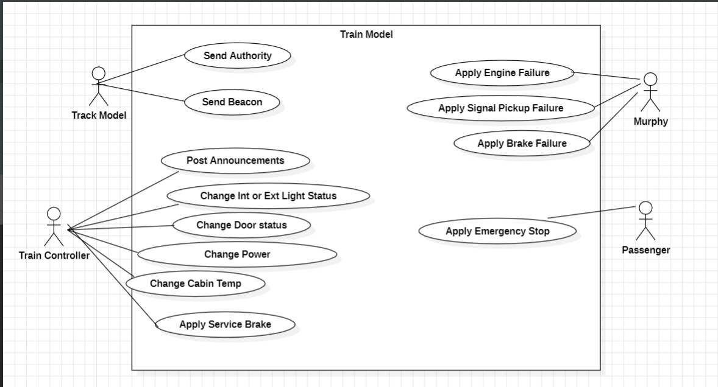

### 5.2.6 Train Controller

#### 5.2.6.1 Train Controller - Use Case Descriptions

| **Train Engineer selects Kp and Ki for Power Calculations** | |
| --- | --- |
| Actors | Train Engineer |
| Description | The Train Engineer will select a Kp and Ki value for every train that is dispatched. These values are used in power calculations for the train |
| Data | Int –Kp, Int –Ki |
| Stimulus | Whenever a Train gets dispatched |
| Response | The Train Controller will store these values and apply them to the power calculation formula whenever the desired speed is changed |
| Comments | If there is an engine failure, the engine will have no power |

| **Train Driver Decrease the Speed** | |
| --- | --- |
| Actors | Train Driver, Passengers |
| Description | Train slows to a stop |
| Data | Power - int, Braking - Int, Current Speed –int |
| Stimulus | When the train drives over the beacon detecting the train |
| Response | Open doors, turn on lights, announce station |
| Comments | Train vital functions automatically stop the |

| **Train Driver Increases the Speed** | |
| --- | --- |
| Actors | Train Driver, Passengers |
| Description | Train Driver increases the speed so the train can reach its commanded speed |
| Data | Commanded Speed - Int, Speed Lim -int, Current Speed –int, Int, Power - int, Braking - Int |
| Stimulus | When the train receives authority and commanded speed that is greater than zero, when the train is currently stopped |
| Response | Train Driver slowly increases the power output to the train in order reach commanded speed |
| Comments | If there is an engine failure, the engine will have no power and the train will not leave,  If there is an pickup failure, the train will not leave the station |

| **Train Driver Creates an Announcement** | |
| --- | --- |
| Actors | Train Driver, Passengers |
| Description | Train Driver enters announcement it wants to be spoken to Passengers |
| Data | Announcement –string |
| Stimulus | When train driver inputs to the announcements to the UI |
| Response | The Train Controller will pass the information onto the Train Model to be outputted via the speakers |
| Comments | If in automatic mode, the driver will not be able output anything to the speakers |

| **Train Driver presses the Emergency Brake** | |
| --- | --- |
| Actors | Train Driver |
| Description | Train Driver engages the Emergency service brake in order to prevent an emergency question |
| Data | Emergency Brake –bool, Power - int, Braking –int |
| Stimulus | Train Driver presses the ‘Emergency Stop’ Button |
| Response | Train Controller outputs zero power and calculates an appropriate braking margin to bring the train to a stop as fast as possible without injuring the powers |
| Comments | If there is a brake failure, the train will not engage the brakes |

| **Train Driver toggles Exterior Lights** | |
| --- | --- |
| Actors | Train Driver |
| Description | Train Driver presses button to change the status of the exterior lights |
| Data | Exterior Lights –bool |
| Stimulus | When train driver presses the button |
| Response | The Train Controller will pass the information onto the Train Model to be outputted via the lights |
| Comments | In automatic mode, the train driver will not be able to toggle lights |

| **Train Driver toggles Interior Lights** | |
| --- | --- |
| Actors | Train Driver |
| Description | Train Driver presses button to change the status of the exterior lights |
| Data | Exterior Lights –bool |
| Stimulus | When train driver presses the button |
| Response | The Train Controller will pass the information onto the Train Model to be outputted via the lights |
| Comments | In automatic mode, the train driver will not be able to toggle lights |

| **Train Driver Opens/Closes Doors** | |
| --- | --- |
| Actors | Train Driver |
| Description | Train Driver presses a button to open or close the left or right doors |
| Data | Door Status –int |
| Stimulus | When train driver presses the button to toggle the door status |
| Response | The Train Controller will pass the information onto the Train Model to be applied to the doors |
| Comments |  |

#### 

| **Train Driver Changes Interior Temperature** | |
| --- | --- |
| Actors | Train Driver |
| Description | Train Driver enters the temperature |
| Data | Temperature –int |
| Stimulus | When train driver inputs number to |
| Response | The Train Controller will pass the information onto the Train Model to change the temperature via the central air unit |
| Comments | This action cannot be completed while the Emergency Stop is activated |

| **Train Model relays emergency notifications to Train Driver** | |
| --- | --- |
| Actors | Train Model, Track Driver |
| Description | Train Model passes on one of the following failures (Power Failure, Brake Failure, Pickup Failure) |
| Data | Power –int, Braking –int |
| Stimulus | When Train Model detects a failure in the system |
| Response | The Train Controller will put power to zero and apply emergency braking system |
| Comments |  |

| **Train Model relays commanded speed and authority to the Train Driver** | |
| --- | --- |
| Actors | Train Model, Train Driver |
| Description | Train Model passes along commanded speed and authority |
| Data | Commanded Speed –int, Authority –int |
| Stimulus | When train driver inputs to the announcements to the UI |
| Response | The Train Controller will pass the information onto the display and adjust speed accordingly to requirements |
| Comments |  |

| **Passenger presses emergency brake** | |
| --- | --- |
| Actors | Train Driver, Passenger, Train Model |
| Description | A passenger has pressed the emergency brake on the train |
| Data | Passenger E Brake –bool |
| Stimulus | When Passenger presses the emergency |
| Response | The Train Controller will put power to zero and apply emergency braking system and inform the driver |
| Comments | Train comes to a stop |

| **Train Model passes beacon information** | |
| --- | --- |
| Actors | Train Driver |
| Description | Train drives over a beacon picking up info, which is relayed to the driver |
| Data | Speed Limits - Int, Next Station - string, Distance to underground entrance - int, Distance to underground exit - int, |
| Stimulus | Passing beacon |
| Response | Relevant information will be presented to the driver, data will be used for backend calculations |
| Comments | Beacon information picked up by train |

| **Train Model model passes current speed** | |
| --- | --- |
| Actors | Train Driver |
| Description | Train model tells train controller the current speed |
| Data | Current Speed - int |
| Stimulus | Speed change signal |
| Response | The train driver or automatic mode will react accordingly |
| Comments | Train changes speed |

| **Train Driver changes mode from Automatic to Manual** | |
| --- | --- |
| Actors | Train Driver |
| Description | Train Driver toggles the mode from automatic to manual |
| Data | Mode – bool |
| Stimulus | When train driver presses the button to toggle mode |
| Response | The Train Controller will switch internal functionality to allow the driver to input information |
| Comments | This action cannot be completed while the Emergency Stop is activated |

#### 5.2.6.2 Train Controller - Use Case Diagram

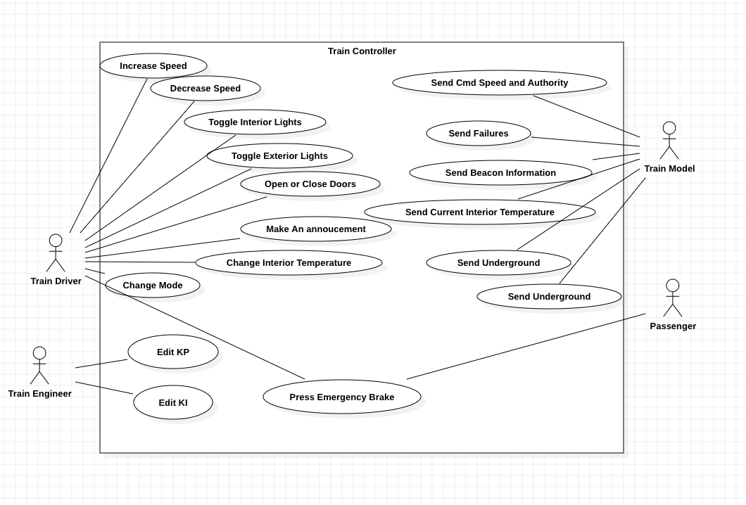

## 5.3 Composition Viewpoint

A deployment diagram models the deployment of artifacts onto nodes. In the case of the Train Control System (TCS), the diagram describes the physical environment in which the code will be deployed. Programs modeling real-world structures used for simulation purposes, such as the track model and train model, are simply to be placed within the world itself.

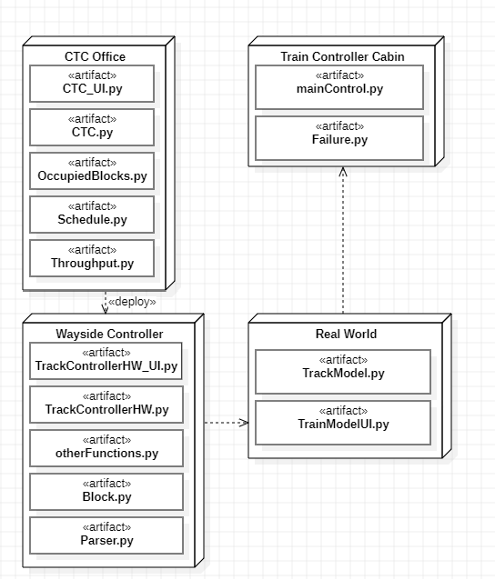

## 5.4 Logical Viewpoint

### 5.4.1 CTC - Class Diagram

The diagram below details the implementation of the class for the CTC office of the TCS system, as well as the subclasses it utilizes. The main CTC class is the CTC_UI class which details the behavior of the UI that the dispatcher interfaces with. It includes an instance of each subclass that makes up the CTC, a pyqtSignal for each output of the CTC to other modules, and methods for each way the user can interact with the system via the UI. Each subclass represents a major responsibility of the CTC. They store the data for that function and each detail methods for interacting with that data that are used internally.

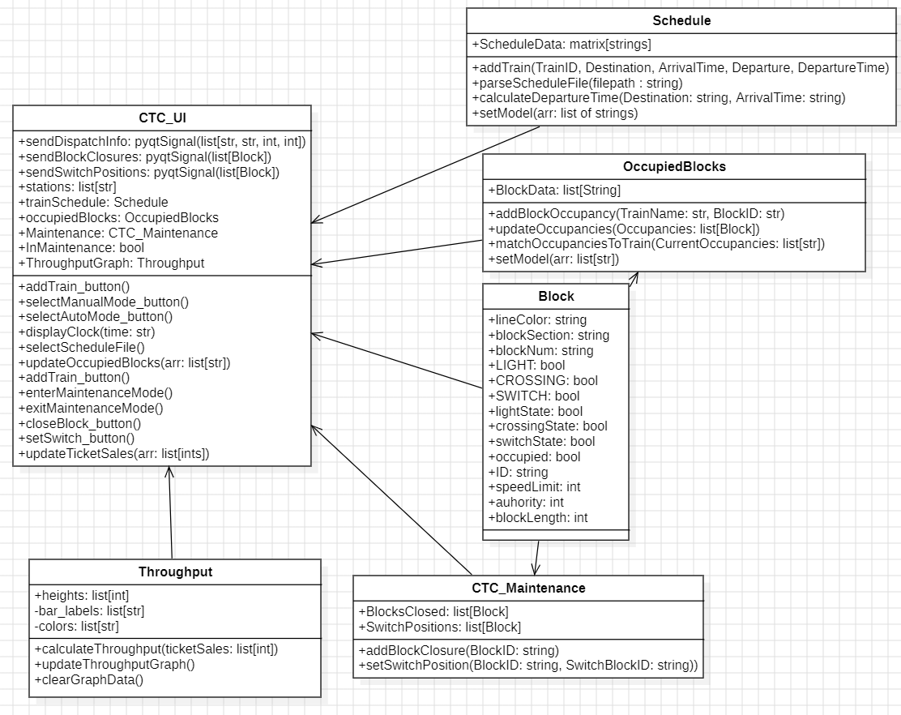

### 5.4.2 Wayside Controller - Class Diagram

#### 5.4.2.1 Software

The diagram below shows how classes are interfaced with one another to make up the Wayside Controller. The Block class is used as a simple struct with no function calls, just attributes. It contains important data about individual blocks and is used by both the Parser class and the Wayside SW. The Parser class is used in the Wayside SW as an object that reads the instructions of the PLC file and is triggered upon any new block occupancy or discarded block. This determines states of switches, lights, and crossings and reflects these changes in the blocks.

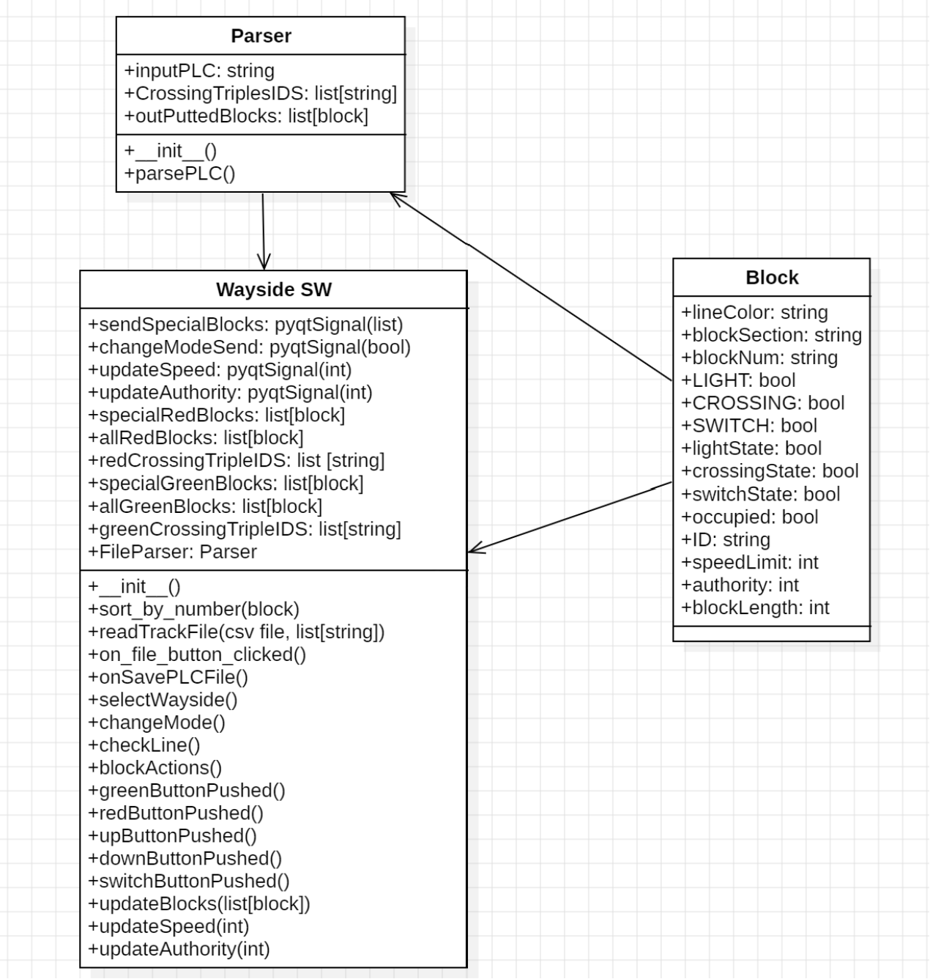

#### 5.4.2.1 Hardware

The following is the class diagram representing the Track Controller (Hardware) module. Operation is nearly identical to that of the software implementation, but with varying function names and slightly different responsibilities. Additionally, automatic mode operation and the results produced from such will occur on a Raspberry Pi system, rather than the Windows 10 computer. The Block class is utilized in the same way in both systems.

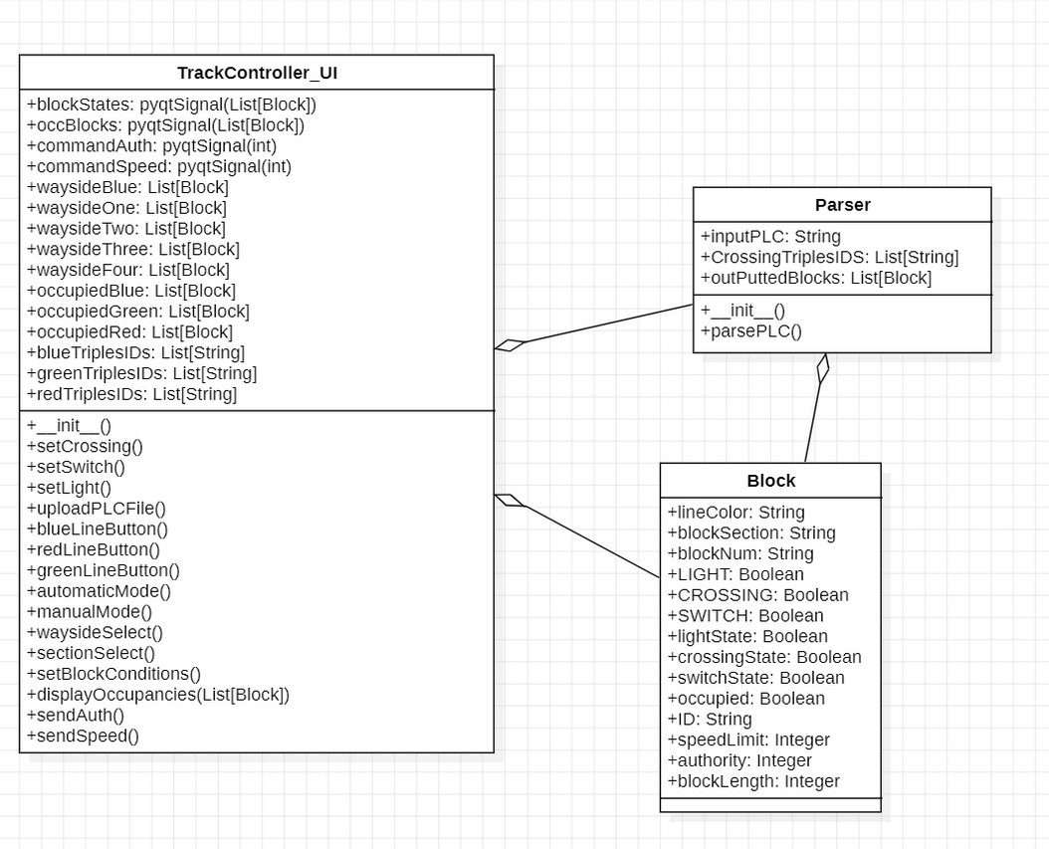

### 5.4.3 Track Model - Class Diagram

Below is an image of the class diagram of the track model. The diagram contains three classes: Block, Data, and Main. The Block class is used as a simple struct with no function calls, just attributes. It contains important data about individual blocks and is used by the Track Model to set and send data. The Data class is the main class where information is pulled into and displayed out to the main UI and other modules.

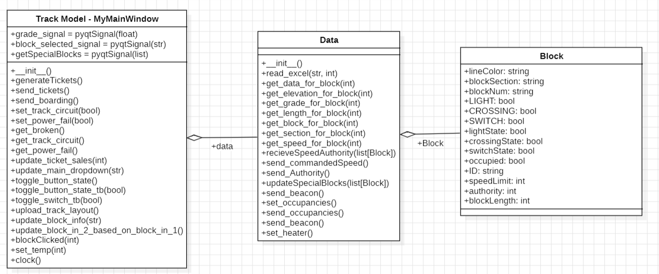

### 5.4.4 Train Model - Class Diagram

Below is an image of the class diagram for the Train Model. It contains the key inputs such as emergency stop status and all the power related calculation methods, such as calculate_force(), calculate_acceleration() and calculate_acc_velocity(). It also contains attributes related to other inputs/outputs, such as length/width/height of the train etc. All Murphy failure signals also have a dedicated method, as can be seen in the figure below.

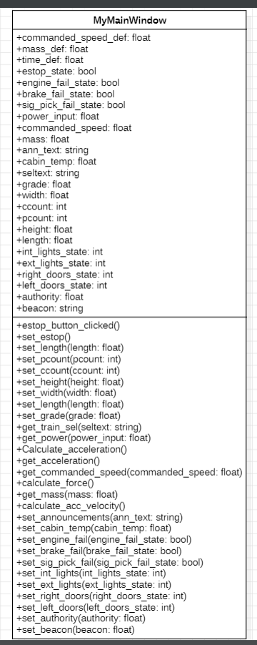

### 5.4.5 Train Controller - Class Diagram

Below contains a class diagram explaining the overview of inheritance associated with the Train Controller module. The Train Controller is split into 2 major subclasses, Vital() and Non_Vital() which represent the type of tasks that the Train Controller must complete The ‘Vital’ class has four more subclasses that further sub-divide the tasks they have to complete. They are divided into Failure, Power, Speed, and Authority related tasks. It is to be noted, the relationship of the top class to TC_Main_Window. Train Controller instantiates an object of this class, all the attributes of the User Interface are edited directly by functions, instead of creating individual class attributes.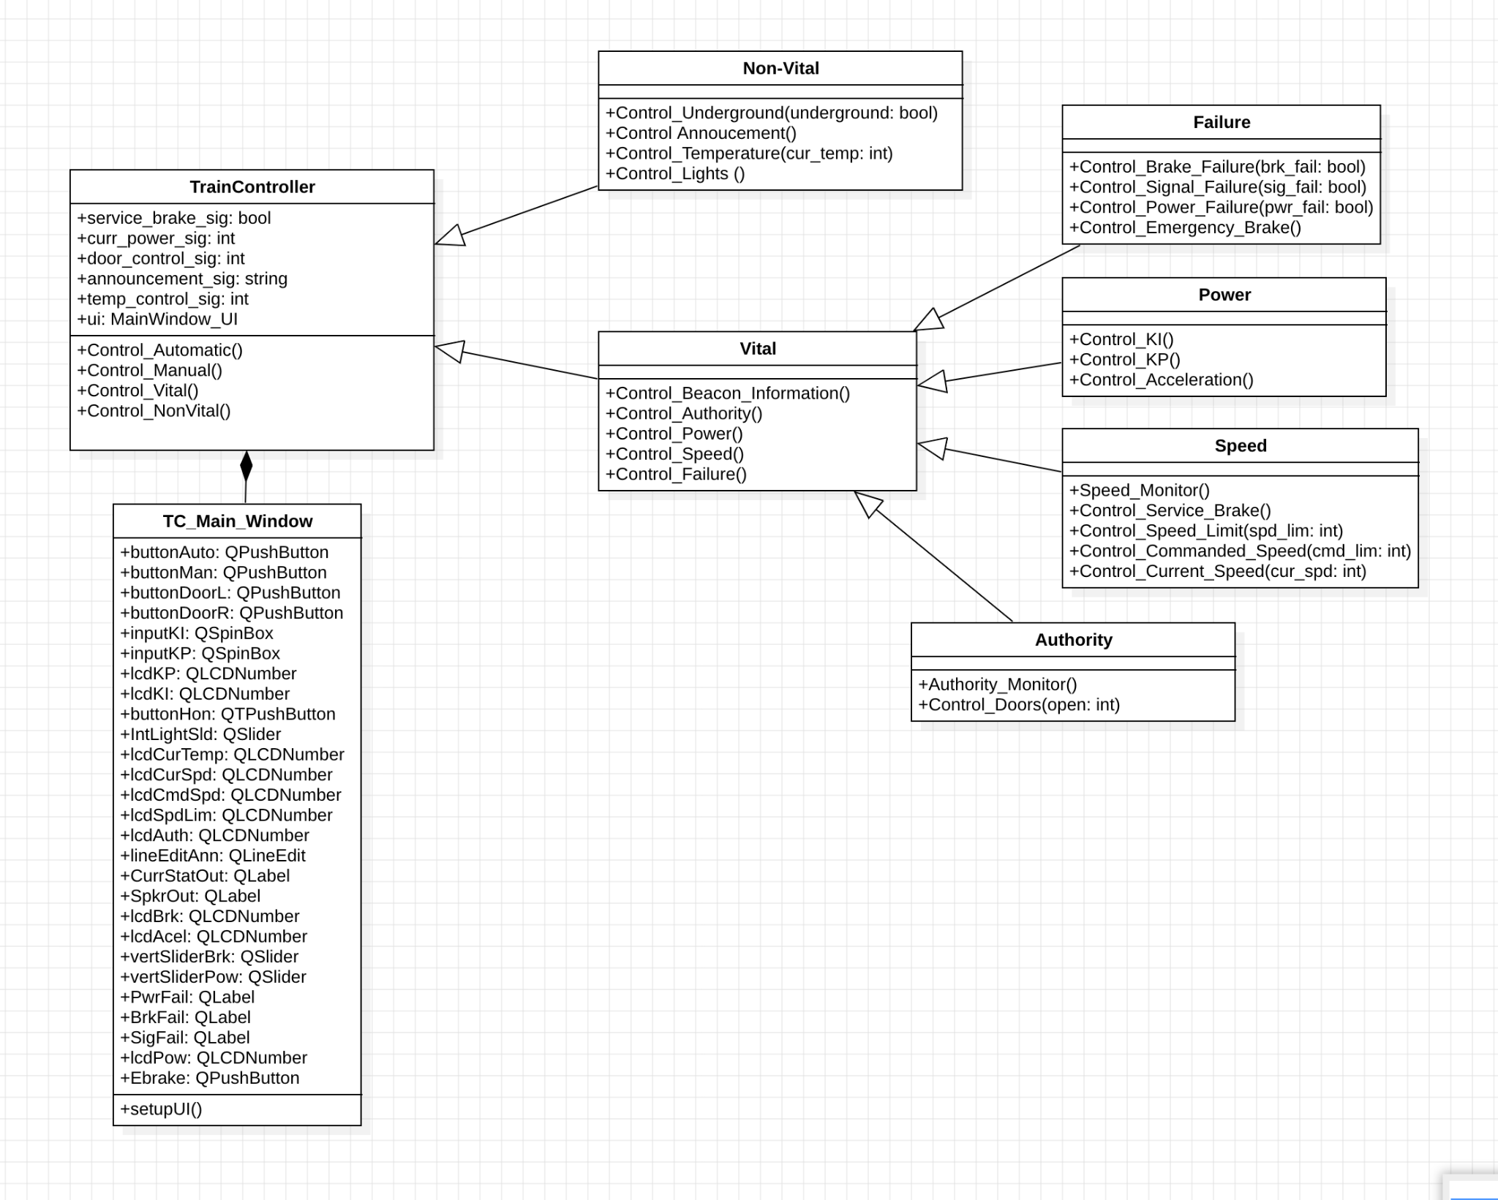

## 

## 5.5 Dependency Viewpoint

### 5.5.1 CTC

The diagram below will show the interactions of the CTC office. These include the outputs of the CTC to the Wayside Controller and to the dispatcher, the sole user of the CTC. The CTC’s behavior is dependent on the inputs from the dispatcher, the wayside controller, and the track model.

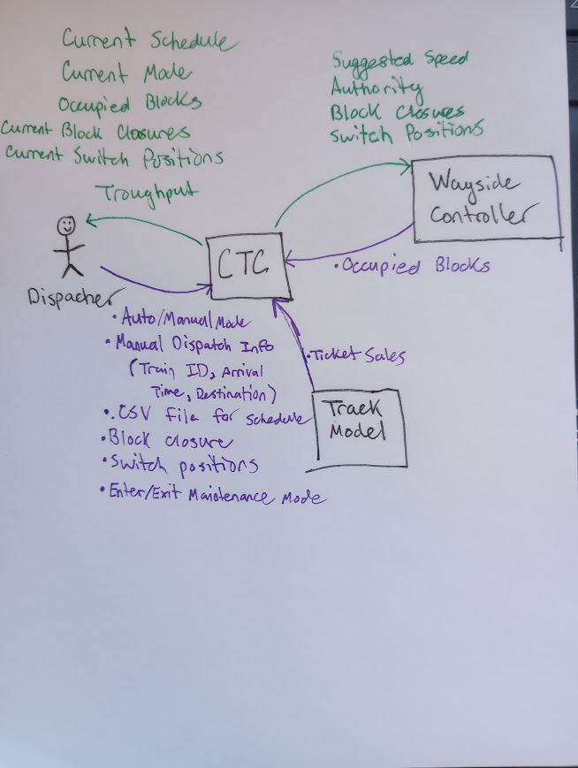

### 5.5.2 Wayside Controller (Software & Hardware)

This diagram outlines all interactions between the Wayside controller and other modules. Additionally, it displays the interaction between the sole user, the PLC programmer, and the Wayside controller.

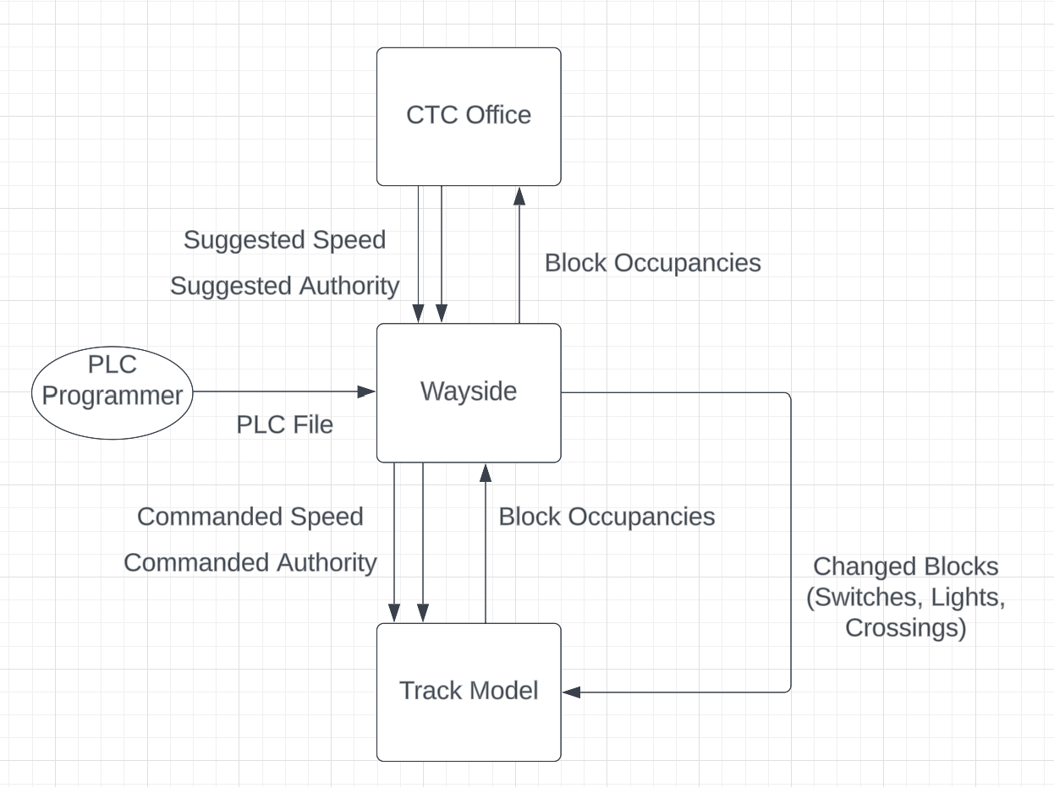

### 5.5.3 Track Model

This diagram depicts the interactions between Track Model with the modules Wayside Controller and Train Model. Additionally, it illustrates the interactions of users Murphy and Track Builder with the Track Model. Certain information, such as Commanded Speed and Authority, is being passed from the Wayside Controller to the Track Model and from the Track Model to the Train Model without alteration.

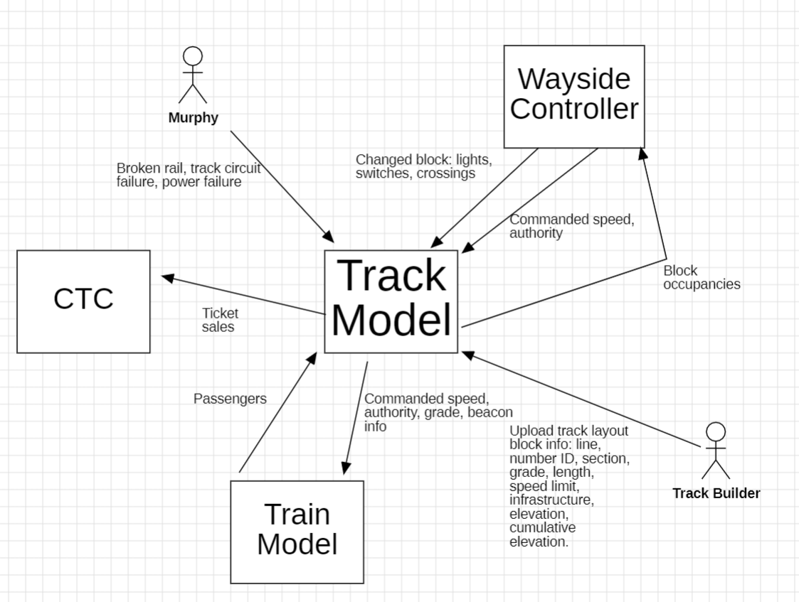

### 

### 5.5.4 Train Model

The Train Model has 4 actors, namely, Track Model, Train Controller, Murphy and Passengers. Track Model sends authority, beacon, commanded speed and grade to the Train Model. The Train Model sends the number of passengers deboarding back to the Track Model. Train controller sends the power function, updated authority, service brake status, interior/exterior light status, cabin temperature and announcements to the Train Model. Murphy sends his three failure signals to Train Model whereas the passengers interacts with the emergency stop button.

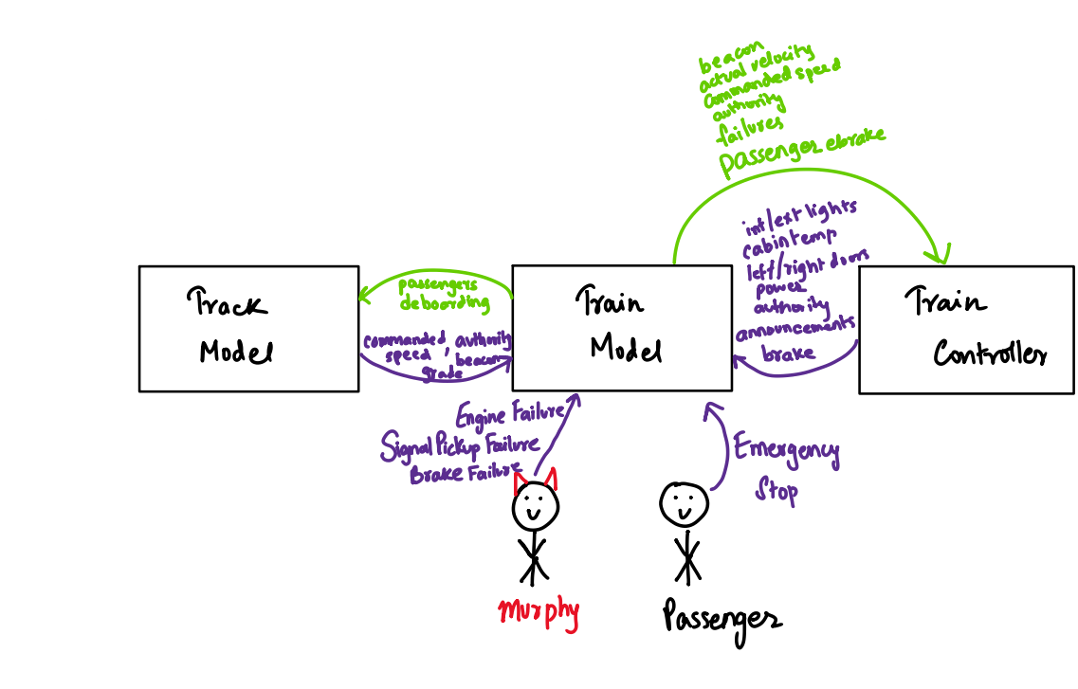

### 5.5.5 Train Controller

The Train Controller takes inputs from the Train Model, the Train Driver, and the Train Engineer. Since the Train Controller is a vital system, it should be able to operate without any input from the Train Driver and Train Engineer. It shall always make a safe choice while sending information for the Train Model to execute. The Train Model mostly provides environmental data (such as current speed) in order to inform the Train Controllers decisions.

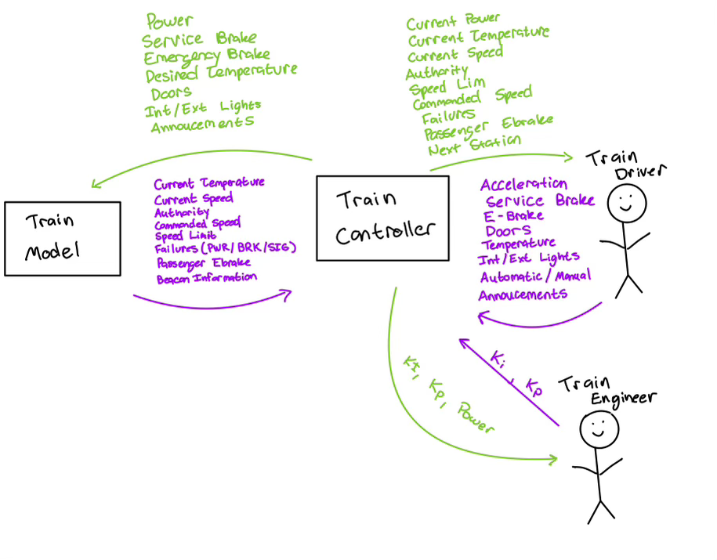

## 5.6 Patterns Use Viewpoint

#### 5.6.1 Block (Class)

The Block class is an object repeatedly used by several different modules within the Train Control System (TCS). The Block class holds solely attributes and no methods. These attributes include data such as identification of the block (line, section, number), as well as length, grade, etc. This class also holds attributes indicating light, switch, and crossing states if those attributes are applicable to said block. The track model module relays block occupancies to the wayside controller on a fixed time interval by sending a list of Block objects. These occupancies are relayed to the CTC office. Additionally, upon changing block attributes (lights, switches, crossings), altered blocks are sent to the track model module.

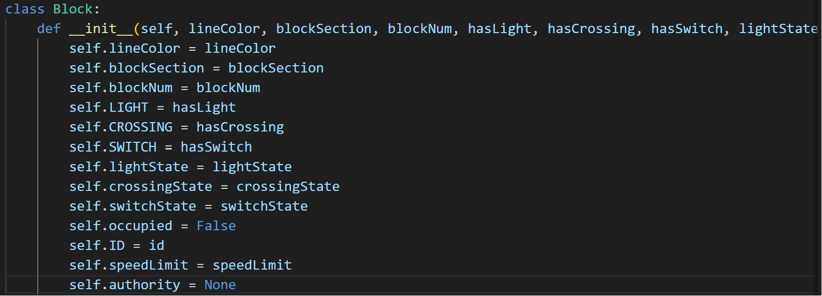

## 5.7 Interface Viewpoint

### 5.7.1 CTC - UI

The dispatcher is the only user who interacts with the CTC UI. The dispatcher can dispatch a train manually, or they can enter automatic mode and upload a schedule to auto populate the schedule. The dispatcher can also enter maintenance mode to close blocks or set switch positions.

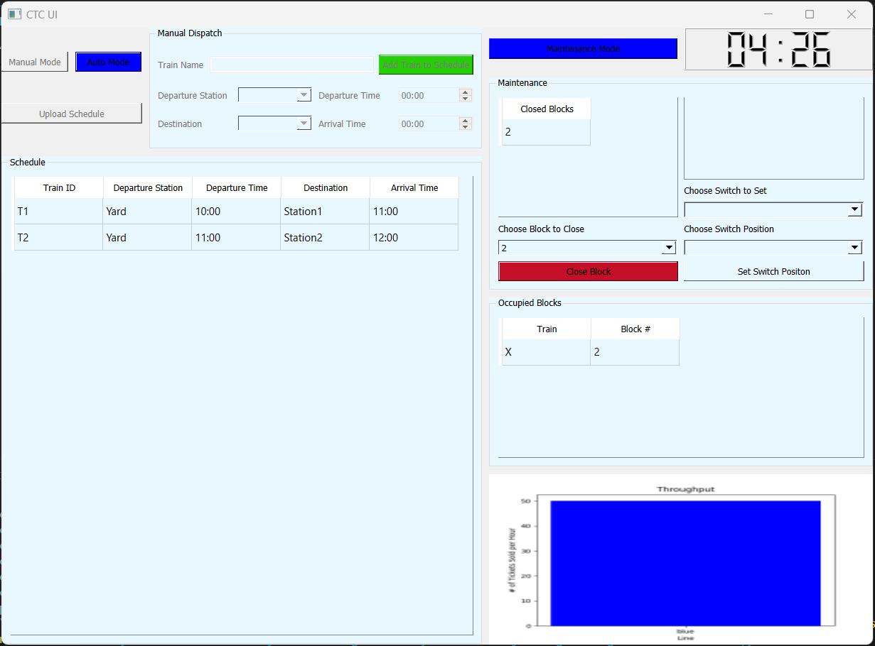

### 5.7.2 Wayside Controller - UI

#### 5.7.2.1 Software

When the programmer first opens the Wayside SW UI, he is required to pick a line before he does anything else. From here, he will have to pick a wayside and more options are now able to be selected. The File button now allows a PLC File to be inserted. Picking a wayside also displays a static image of the block sections covered by that wayside. If he wants to stay in Manual mode, he can select Block Ids from the dropdown menu. Upon selecting a block, he will be able to see what kind of block it is and its status. If the block has a light, the current light status will be shown by its color. If the block has a crossing, the current crossing status will be shown by a highlighted UP or DOWN. If the block has a switch, the direction of the switch will be shown. The light and crossing blocks can be changed by clicking the non-colored box. The crossing block can be changed by clicking the CHANGE button. Block occupancies sent by the Track Model are also shown at the bottom.

The programmer has the option to upload a PLC File. After this file is uploaded, he can choose to change to Automatic mode and save the current PLC File. The programmer will still be able to pick a block from the dropdown menu and see its status but will be unable to change its state as all states in automatic are determined by block occupancies.

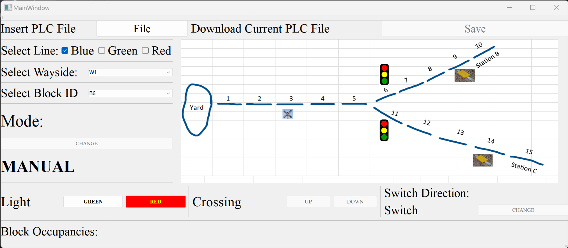

#### 5.7.2.2 Hardware

Clear similarities exist between software and hardware implementations of the wayside controller modules. The system begins in manual operation, as automatic operation can not begin until the PLC programmer uploads a valid PLC file. If a valid PLC file is selected, the system automatically switches to automatic operation. In this mode, all switch, crossing, and light states are changed according to block occupancies, as applied within the PLC file. Automatic mode processing will occur on a Raspberry Pi system, and results are communicated serially to the main program.

The PLC programmer has the option to revert back to manual operation. However, once this is chosen, the system can not be switched back to automatic operation. In manual mode, the PLC programmer may edit the attributes of individual blocks. To select a block, the programmer must select the line that the block is on, the wayside controller that is responsible for overseeing the block, and the block’s section and number. Then, the attributes that the block has are displayed at the bottom of the UI under “Change Block States”. To change the attribute, simply press the button beneath the display of the attribute, and the change will be reflected.

Additionally, block occupancies as well as blocks closed by the CTC office in maintenance mode are displayed clearly at the center of the UI.

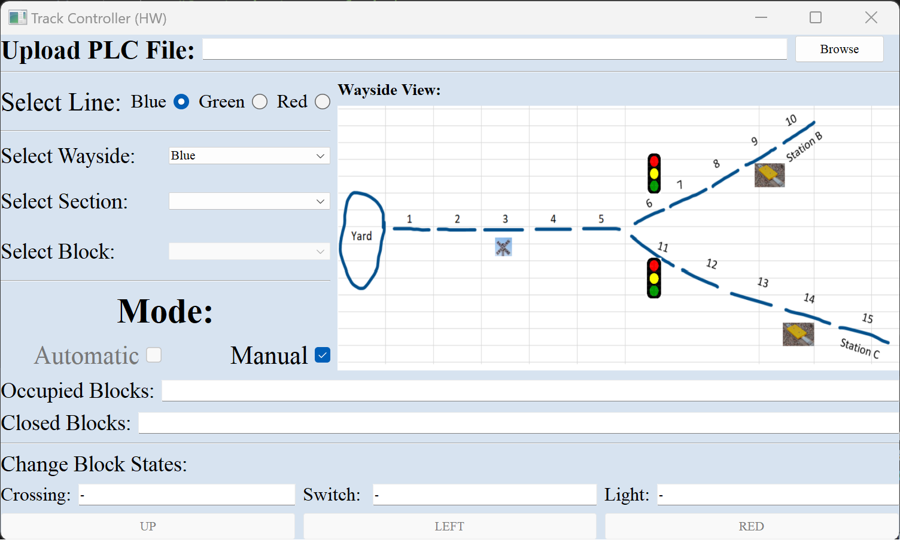

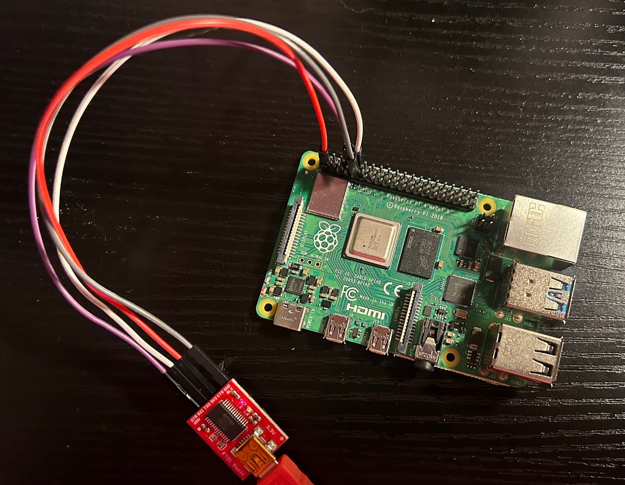

### 5.7.3 Track Model - UI

The picture below depicts the Track Model user interface (UI). This UI is dedicated to users Murphy and Track Builder. Within this interface, the Track Builder can upload an Excel or CSV file, after which live block data will be outputted to the users. Additionally, the Track Model UI enables the Track Builder to select specific lines and blocks to view particular block data. Alongside block data, information about the station, as well as the status of lights and switches, will be displayed to the user. Murphy, as a user, can also indicate and execute failures as needed at the click of a button. Furthermore, the user can set the environmental temperature, which will determine whether track heaters need to be toggled on or off.

### 5.7.4 Train Model - UI

This UI is dedicated to the passengers and Murphy. Murphy can use this interface to deliver any failure signal as he desires. The passengers can use this interface to virtually pull the emergency stop. The UI shows live train statistics for a user-friendly experience and also dedicates a section to the power calculations, emphasizing the power, acceleration and actual velocity value in imperial units.

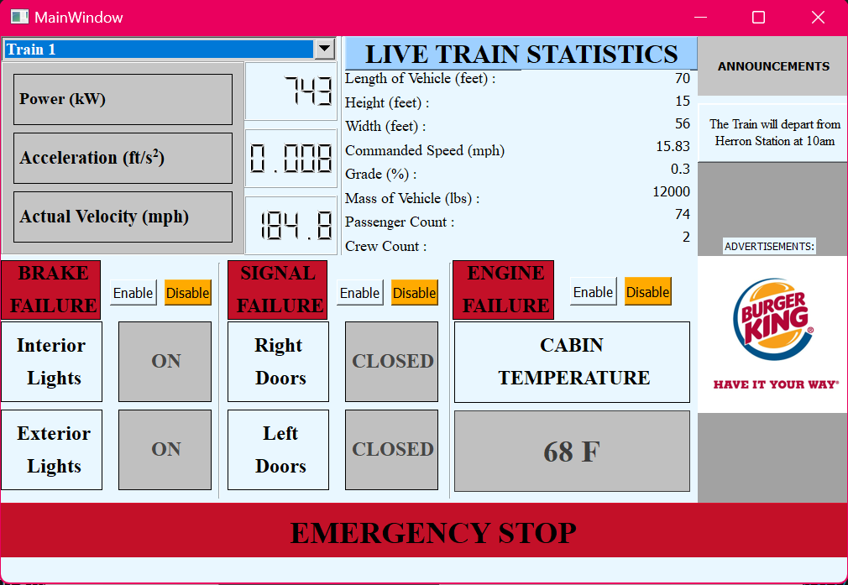

### 5.7.5 Train Controller - UI

The UI is mainly used by the Train Driver, to change user interactions with the Train. It allows them to see important information, like the next station, and current speed. The Train Engineer should only be allowed to edit KI/KP and thus has a segregated piece of the UI.

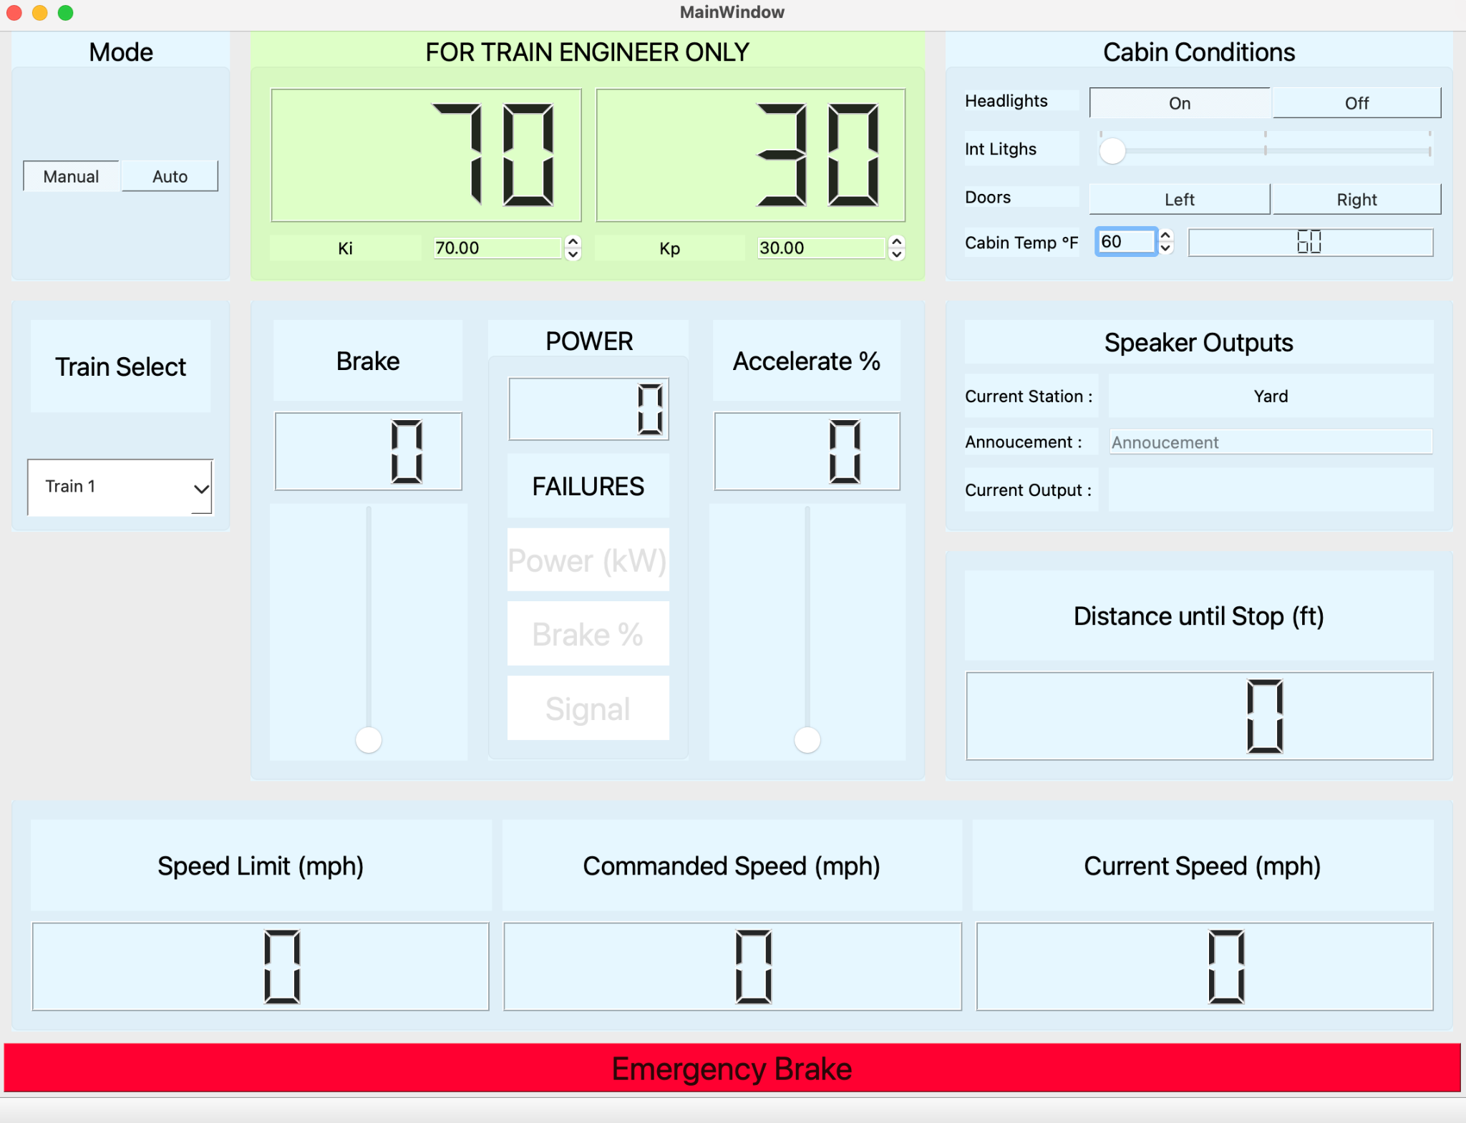

## 5.8 Interaction Viewpoint

### 5.8.1 CTC

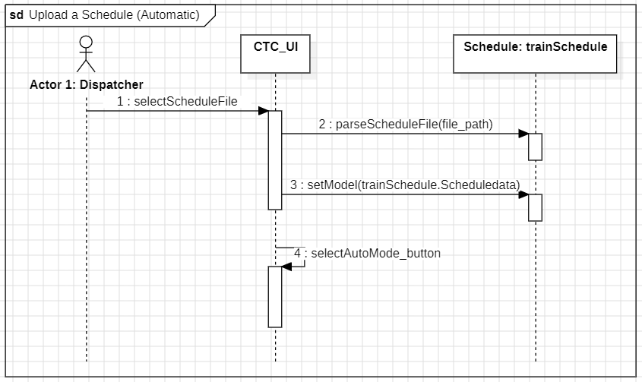

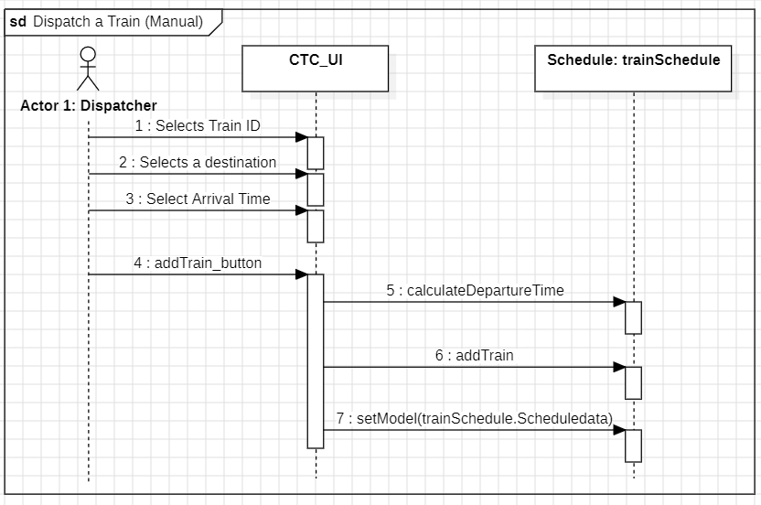

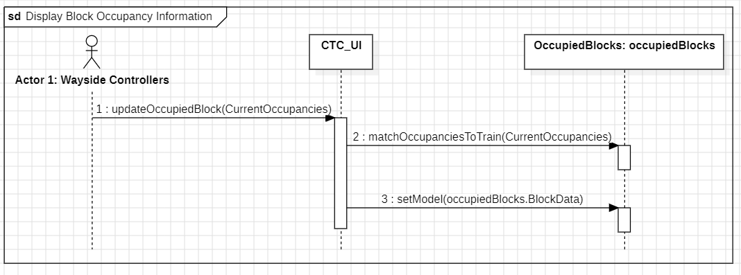

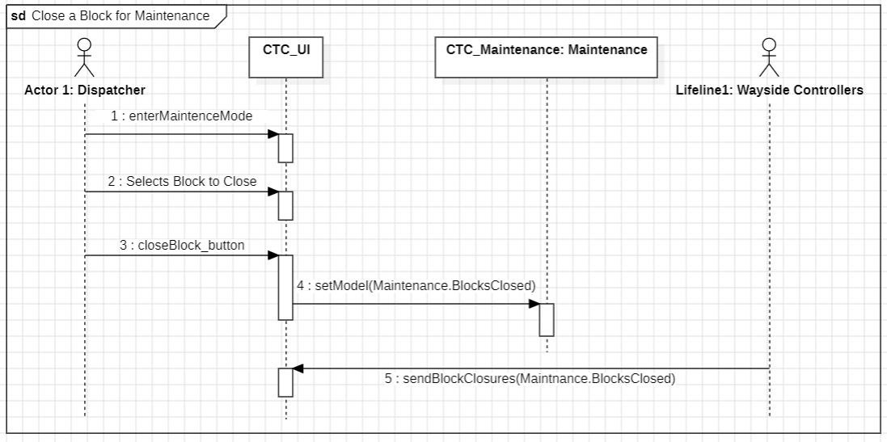

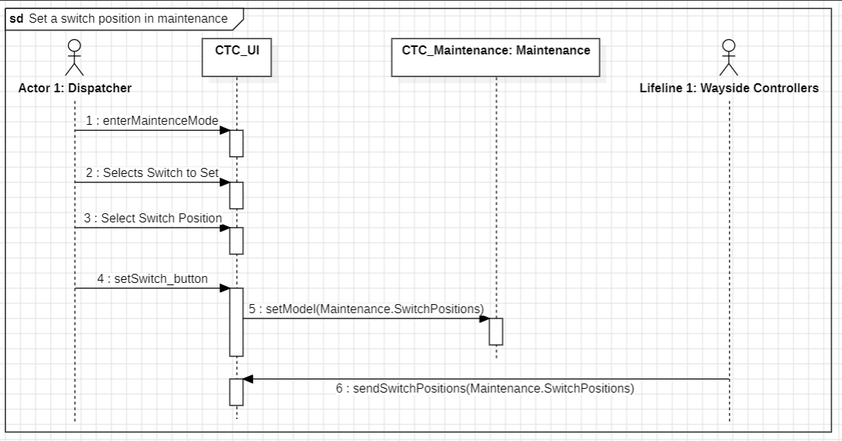

### 5.8.2 Wayside Controller

#### 5.8.2.1 Software

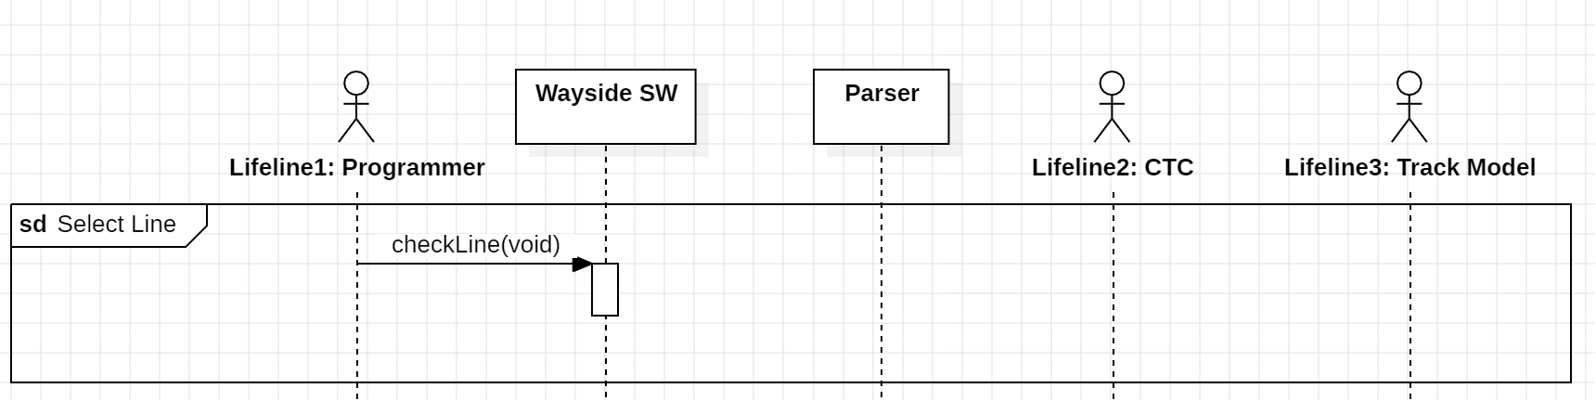

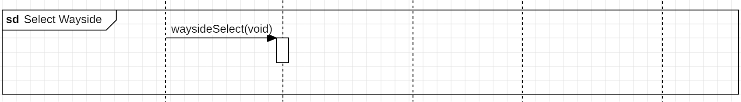

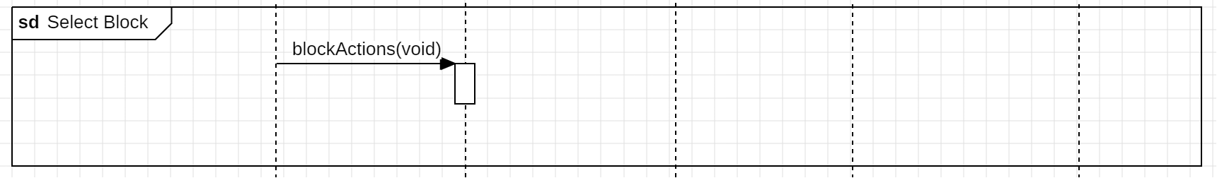

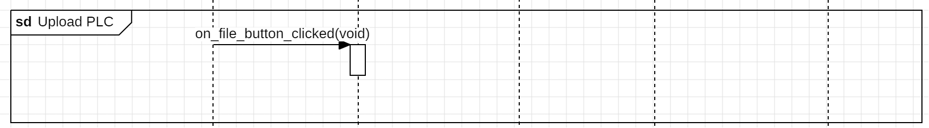

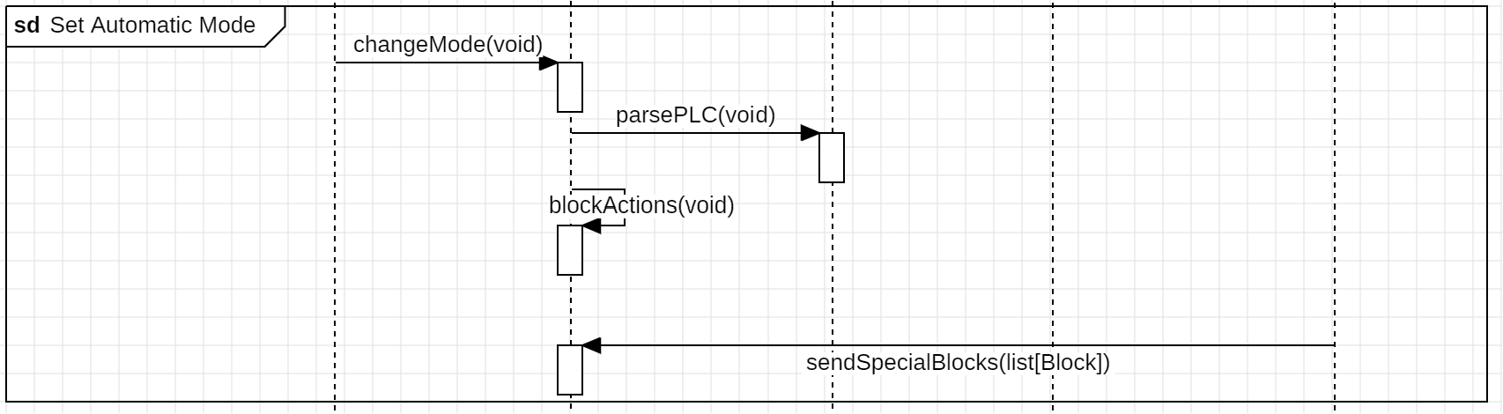

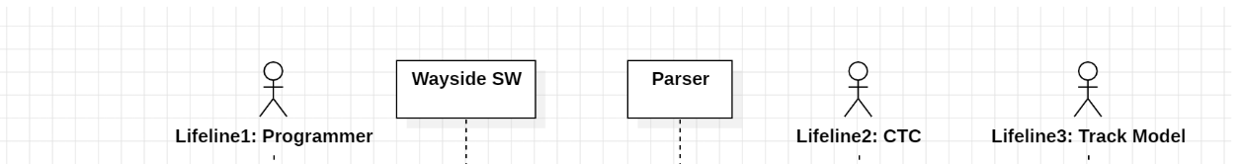

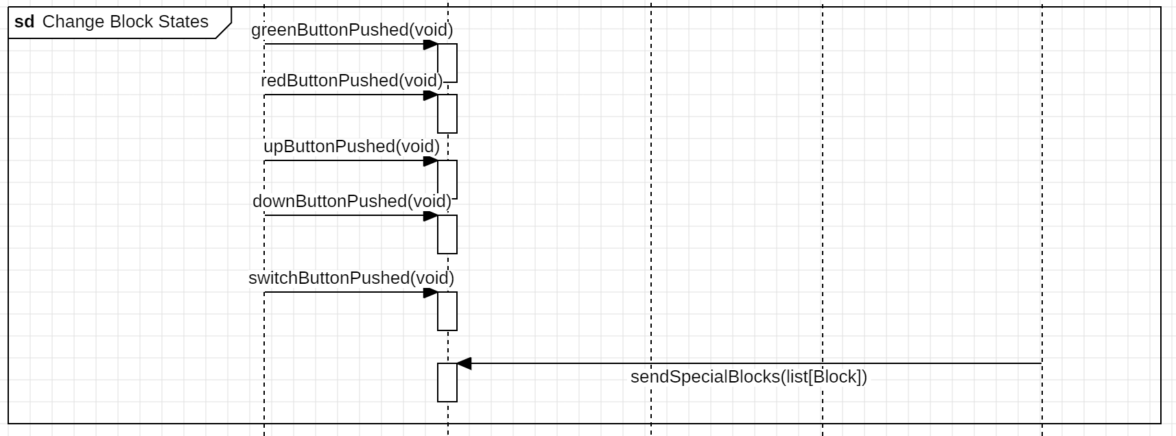

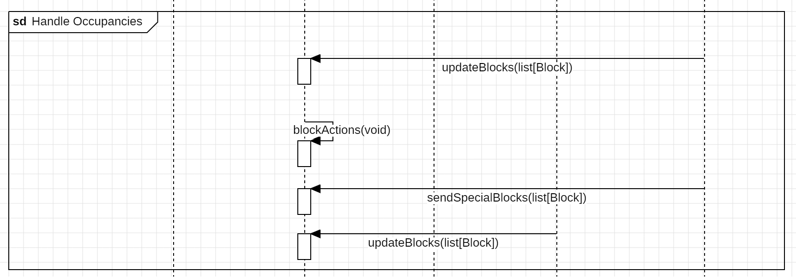

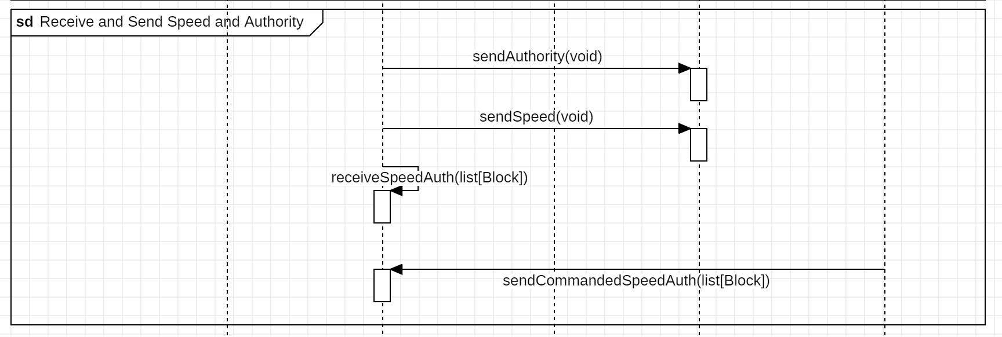



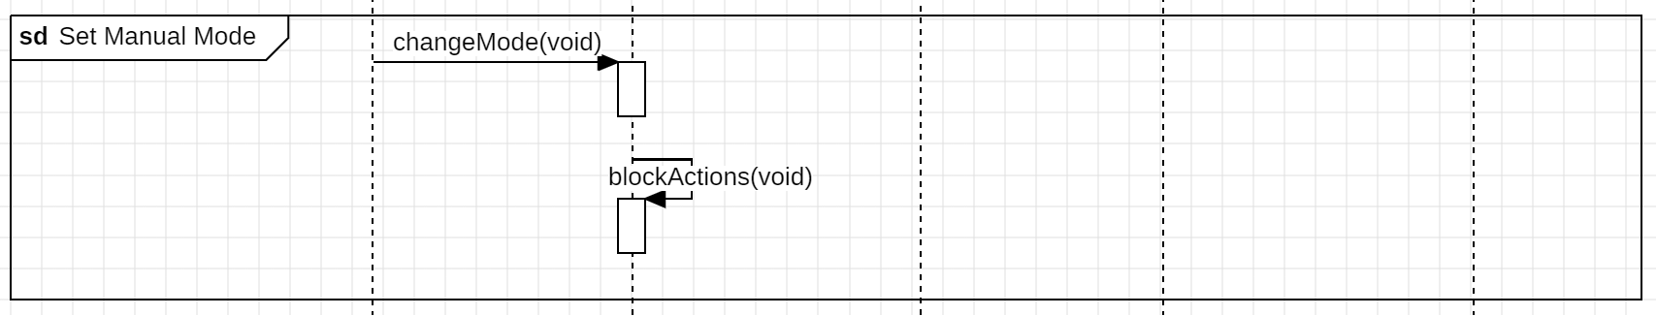

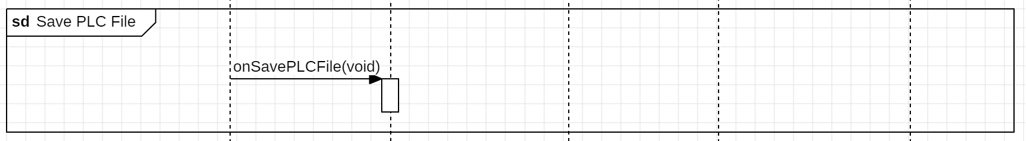

#### 5.8.3.2 Hardware

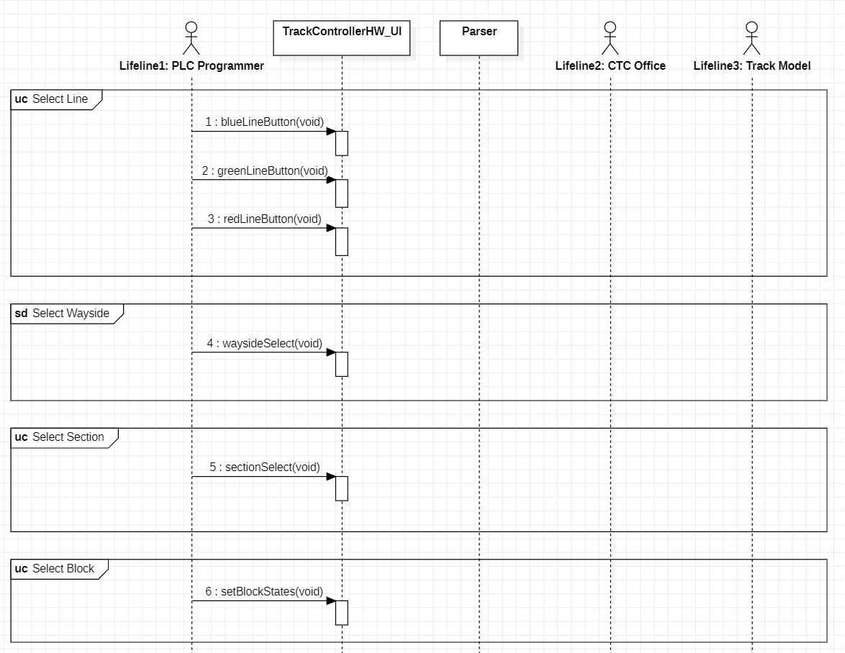

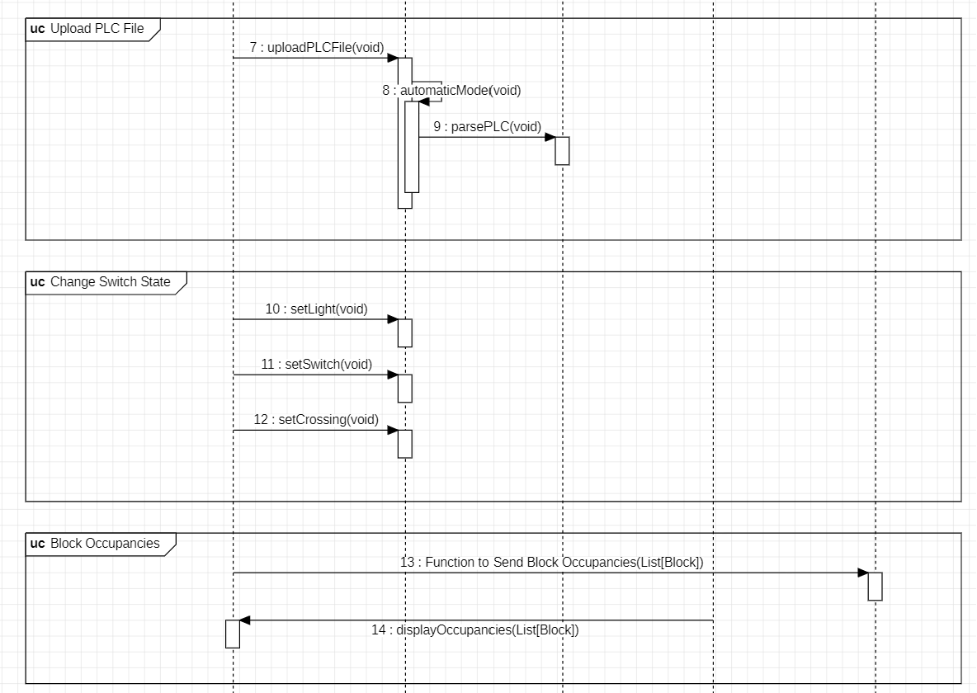

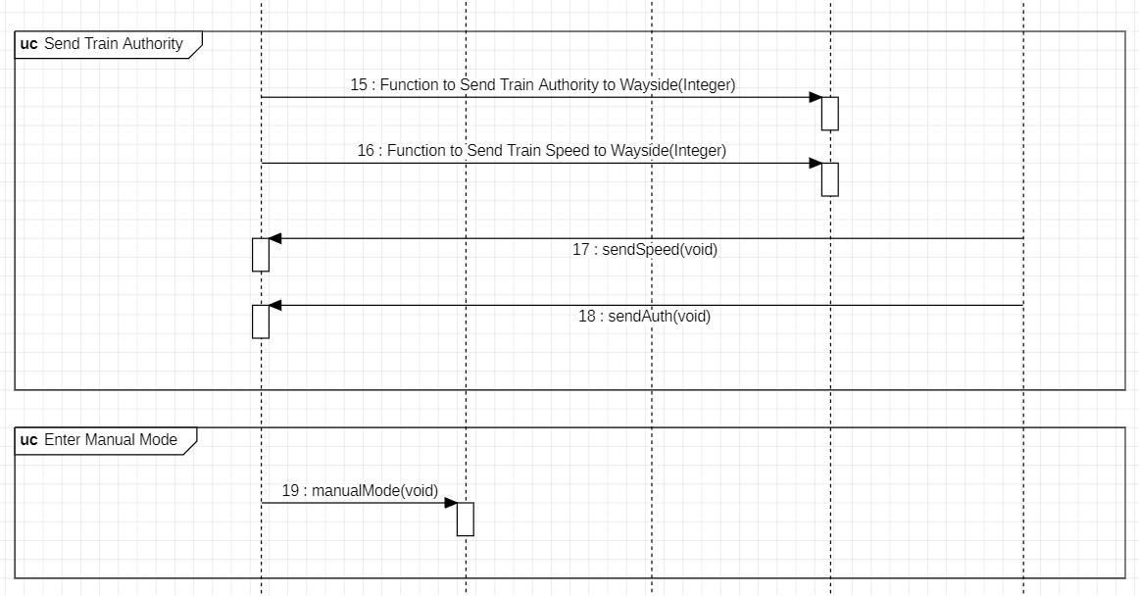

### 5.8.3 Track Model

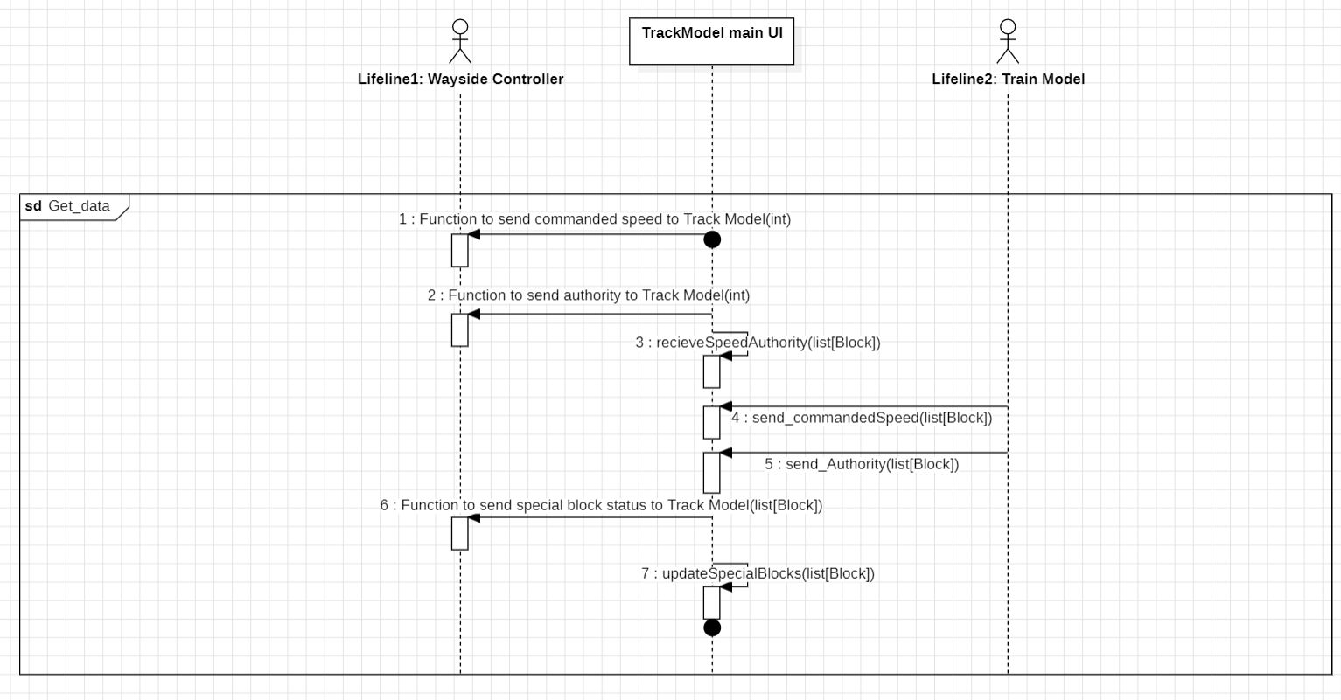

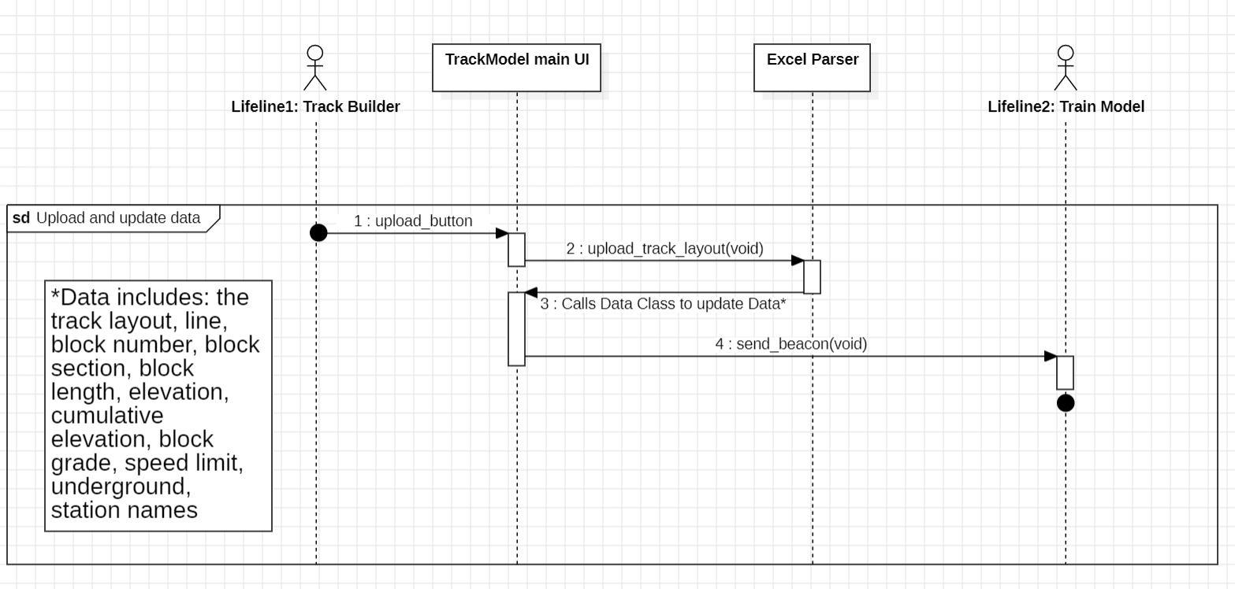

#### 

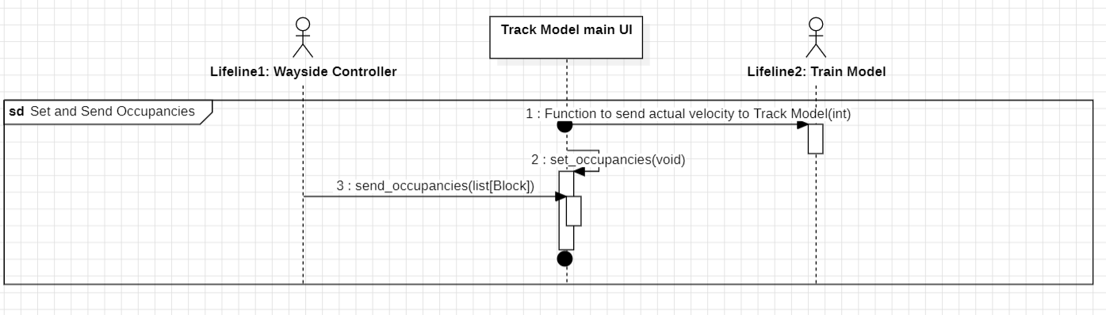

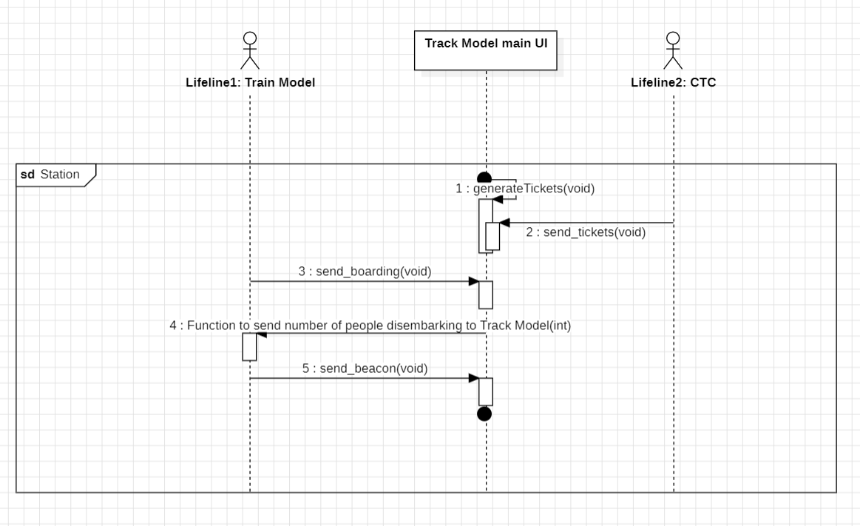

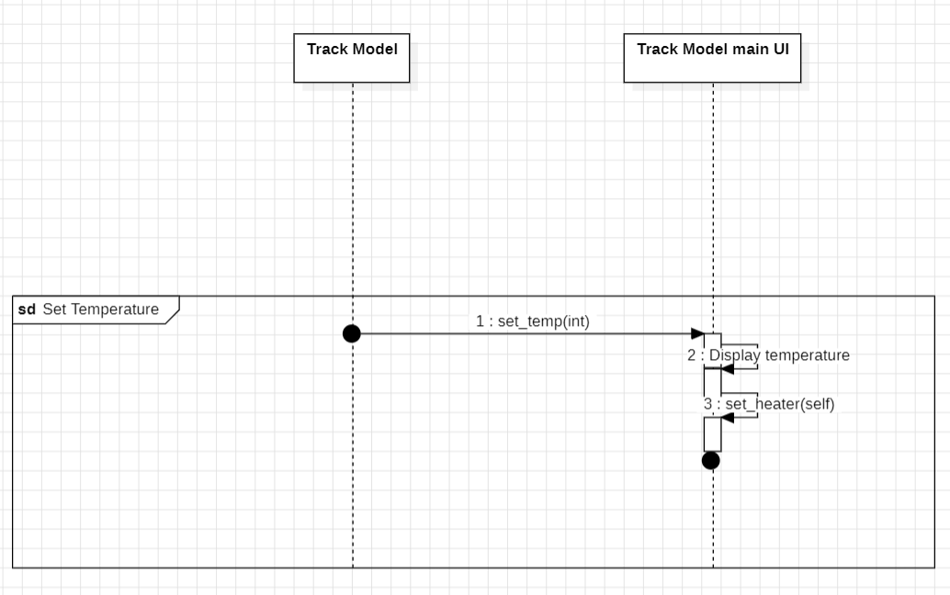

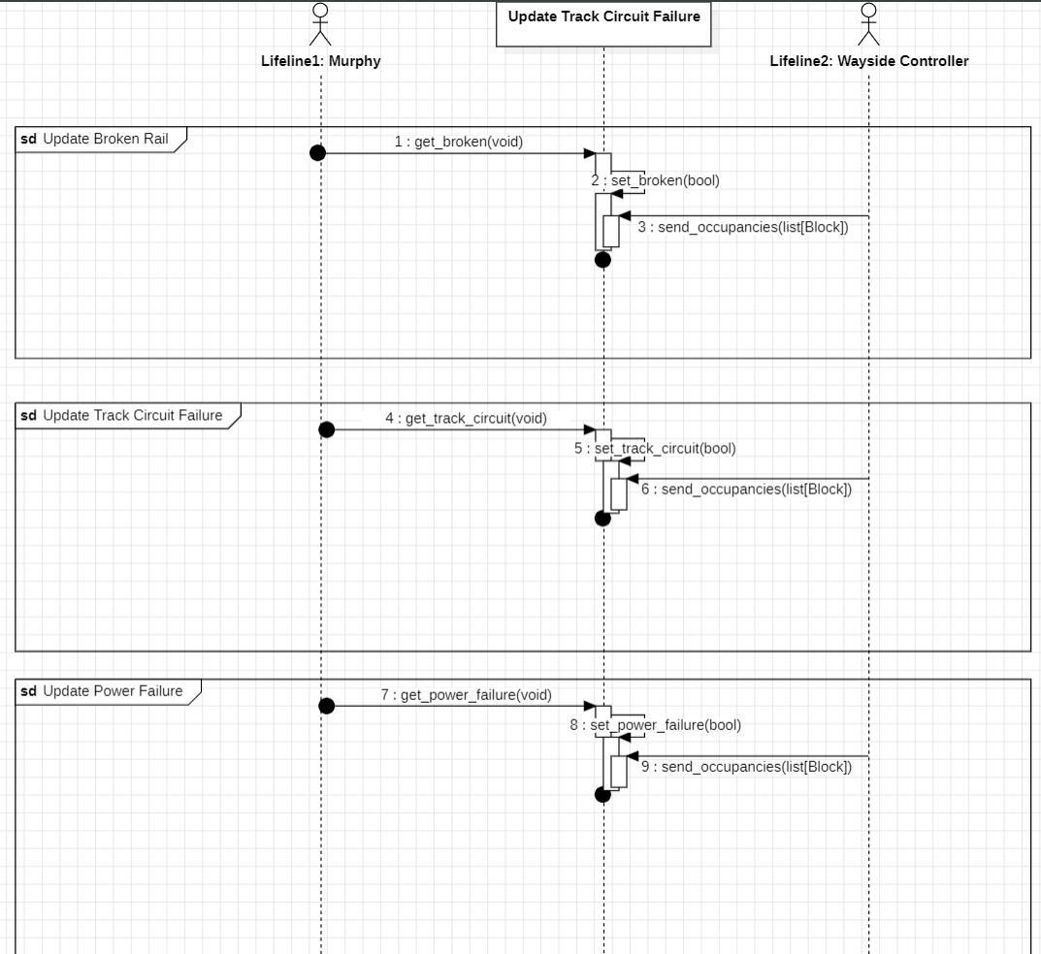

### 5.8.4 Train Model

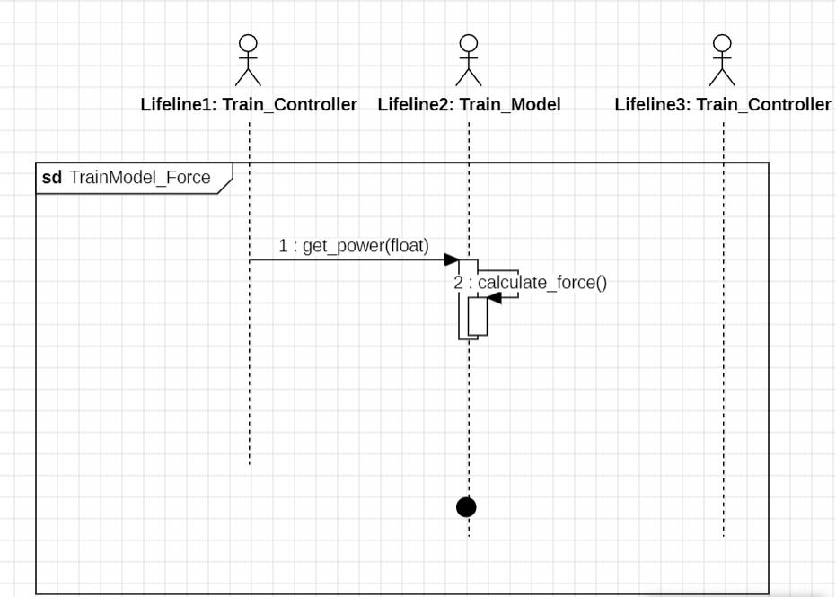

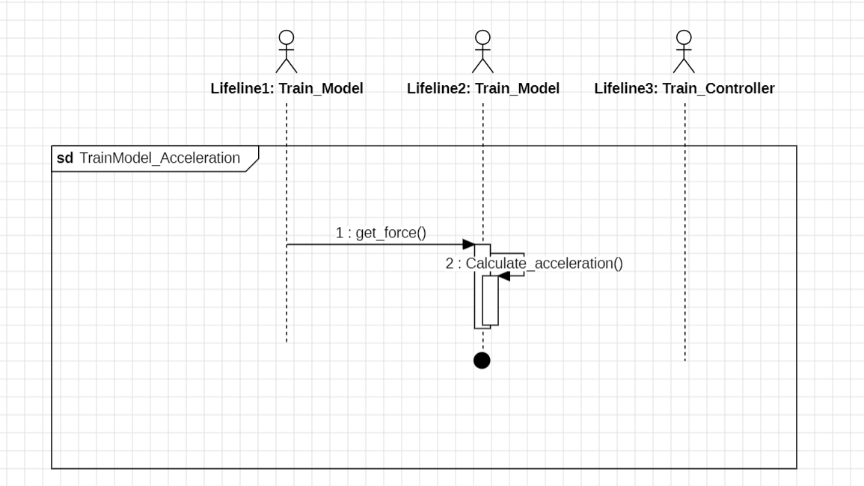

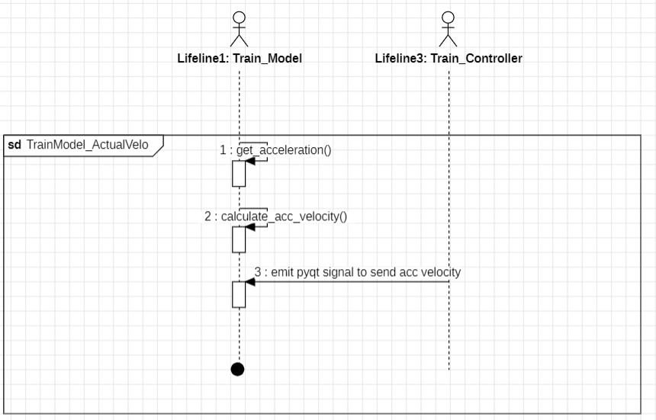

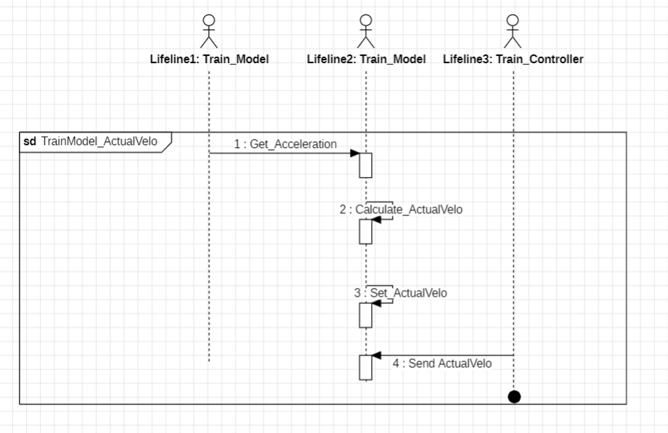

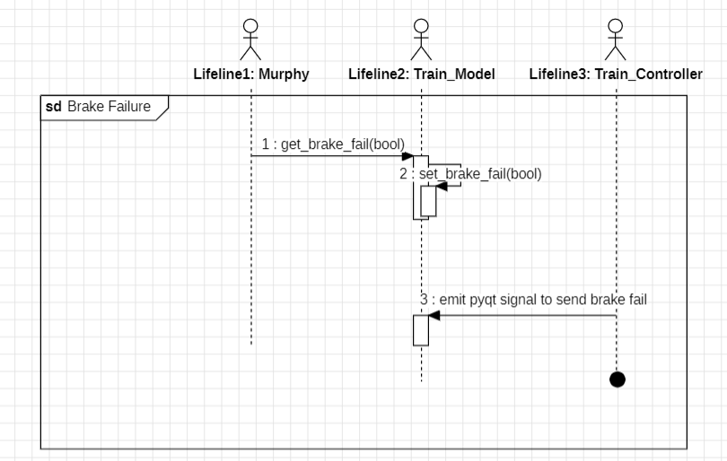

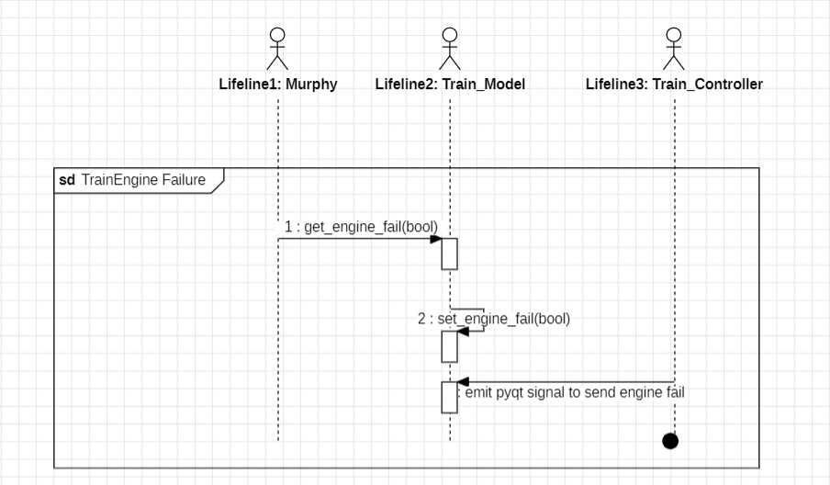

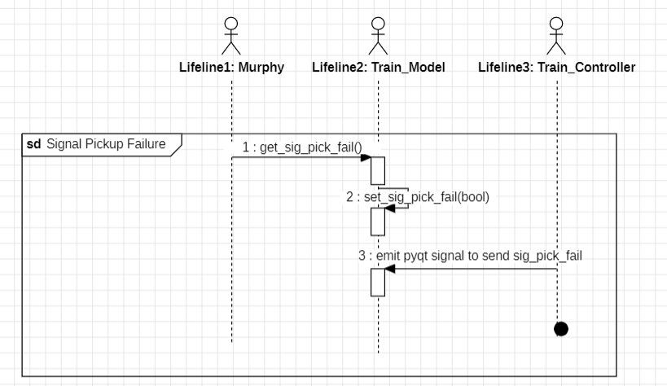

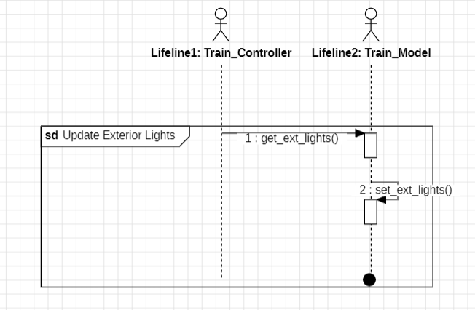

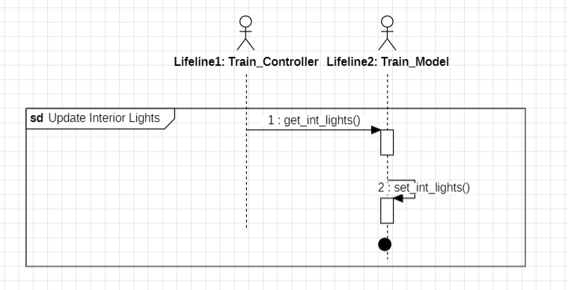

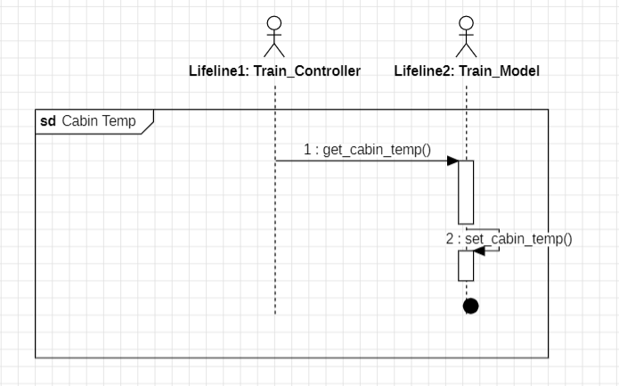

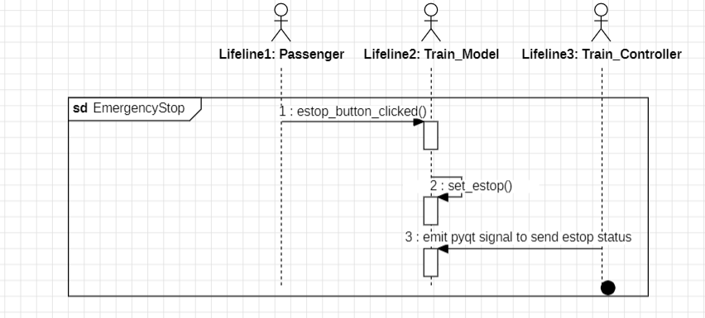

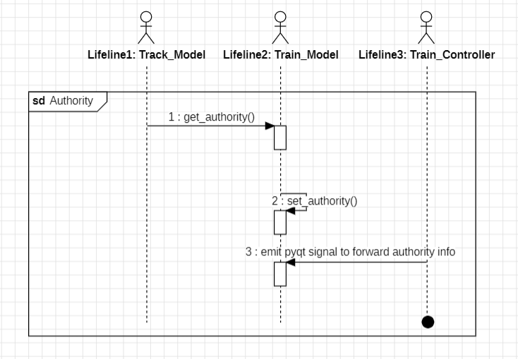

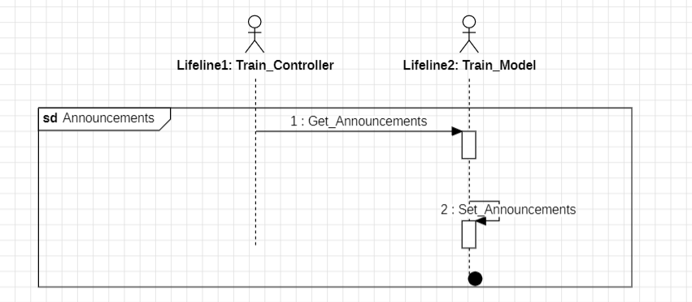

### 5.8.5 Train Controller

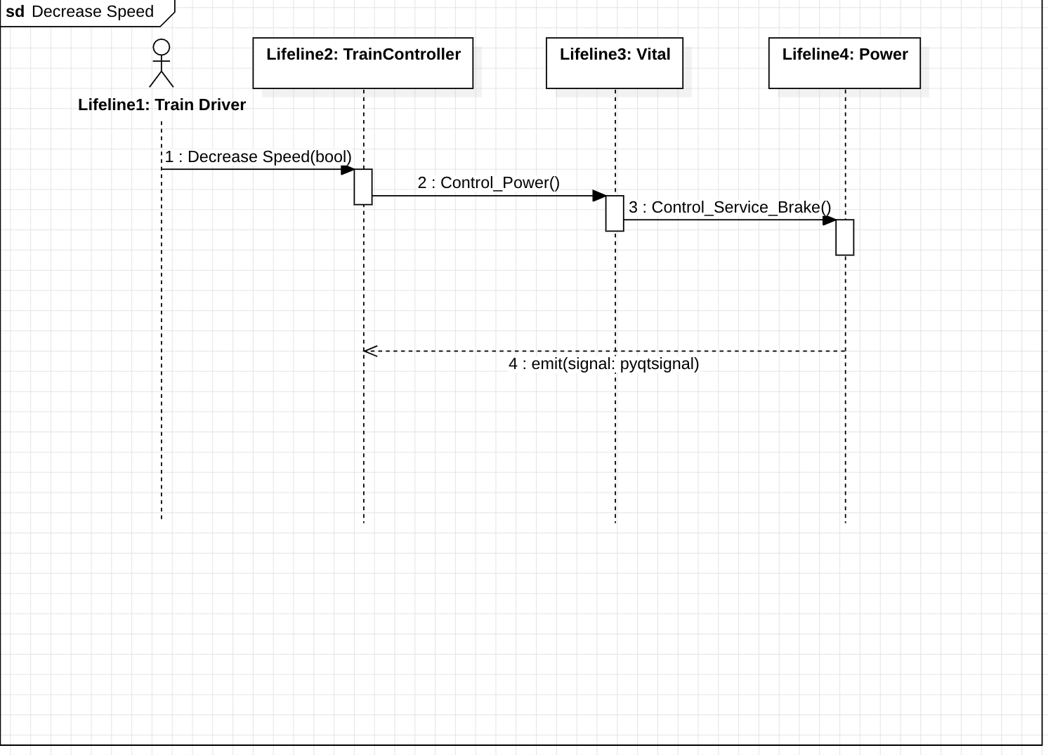

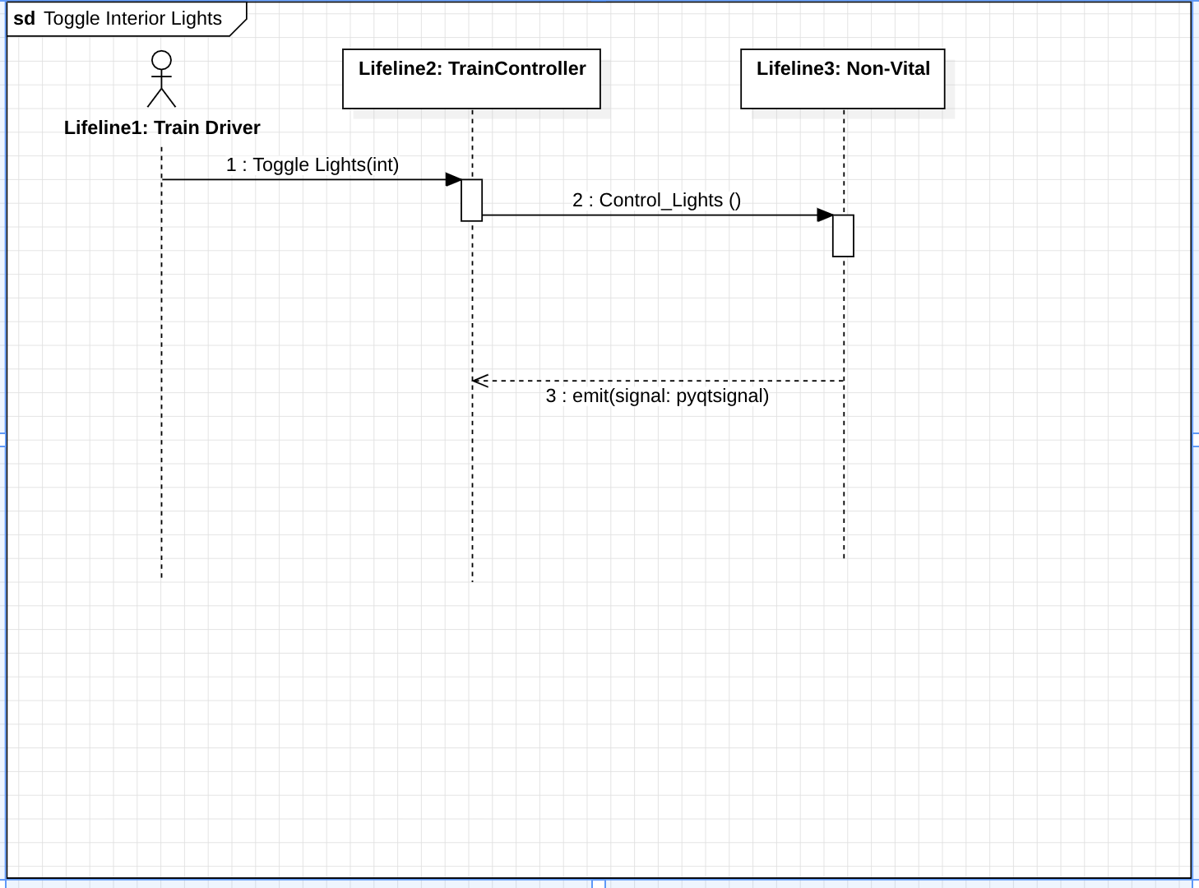

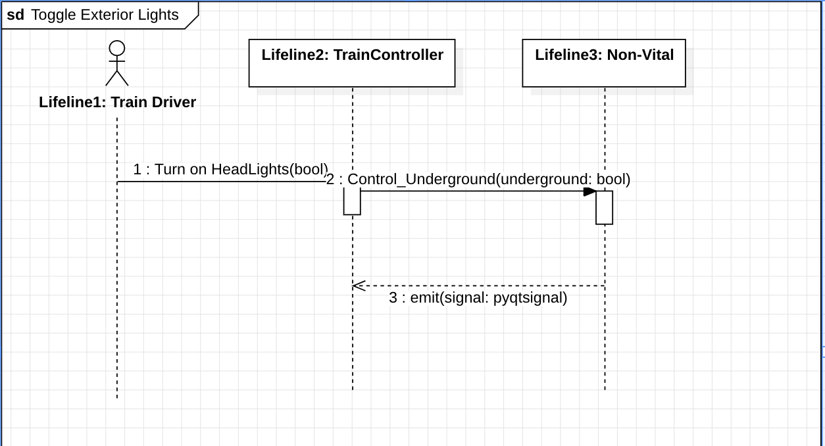

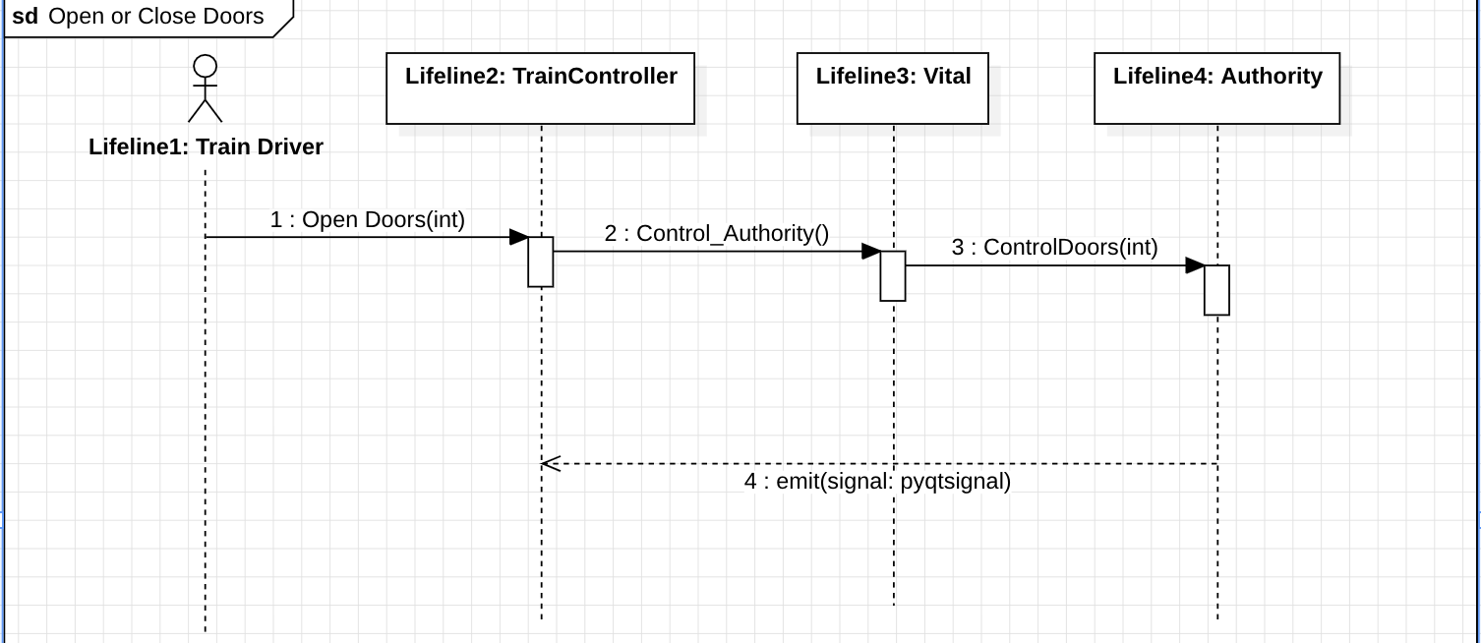

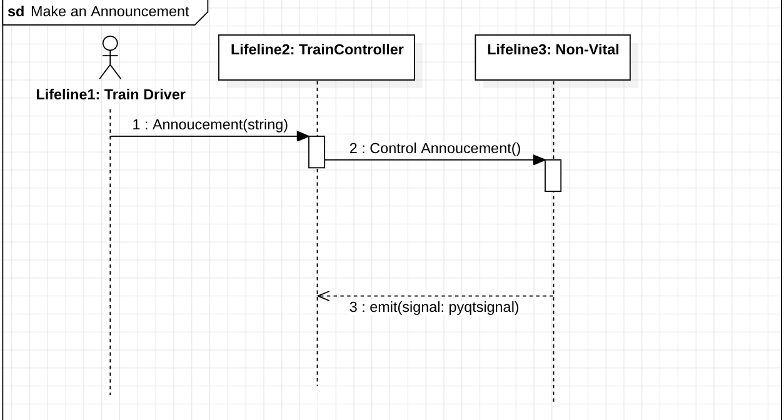

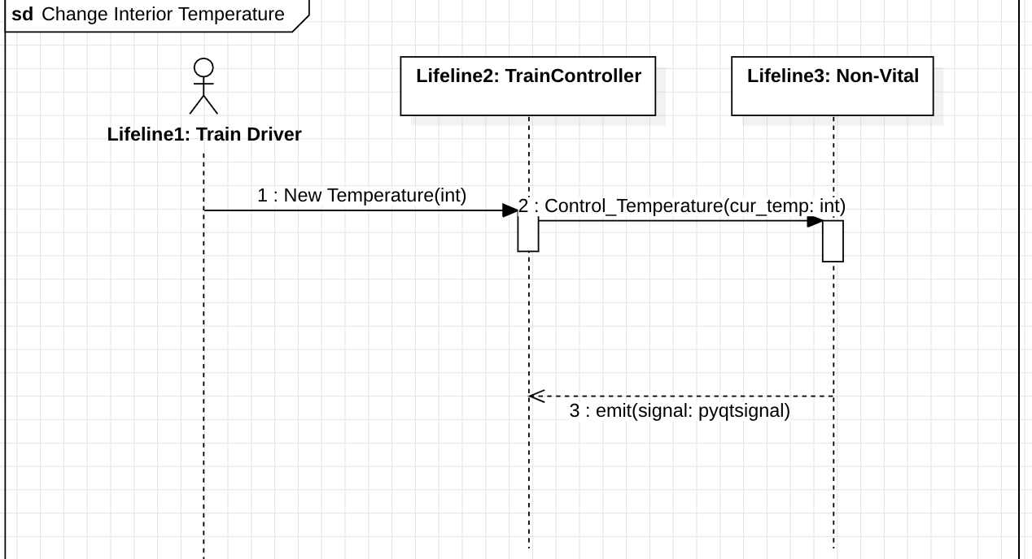

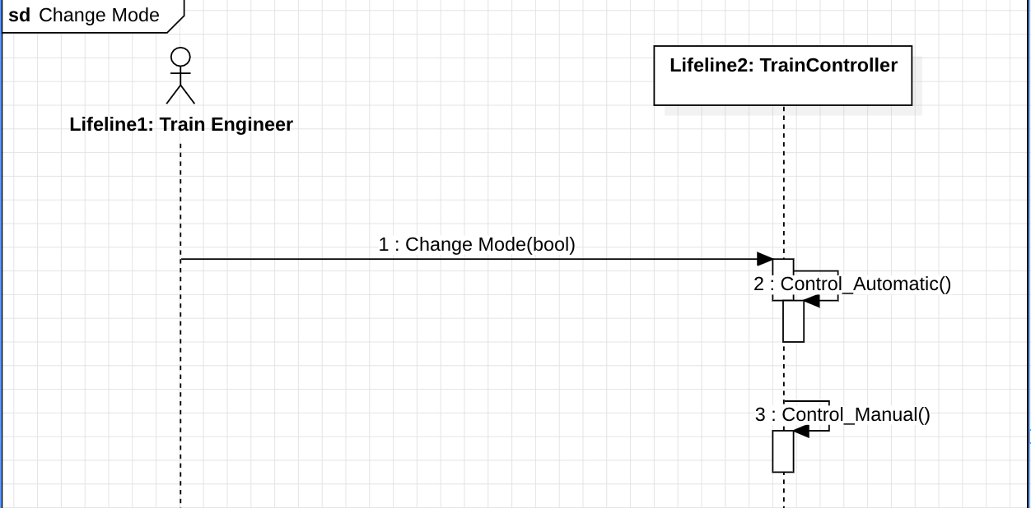

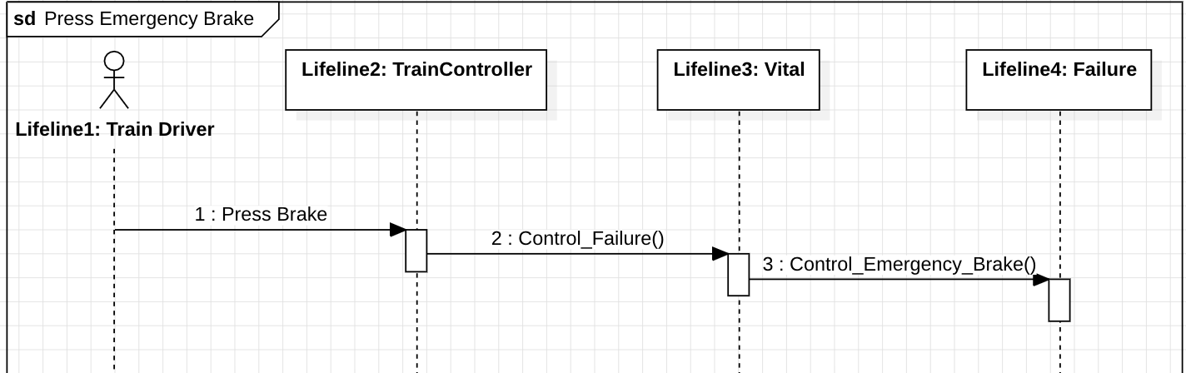

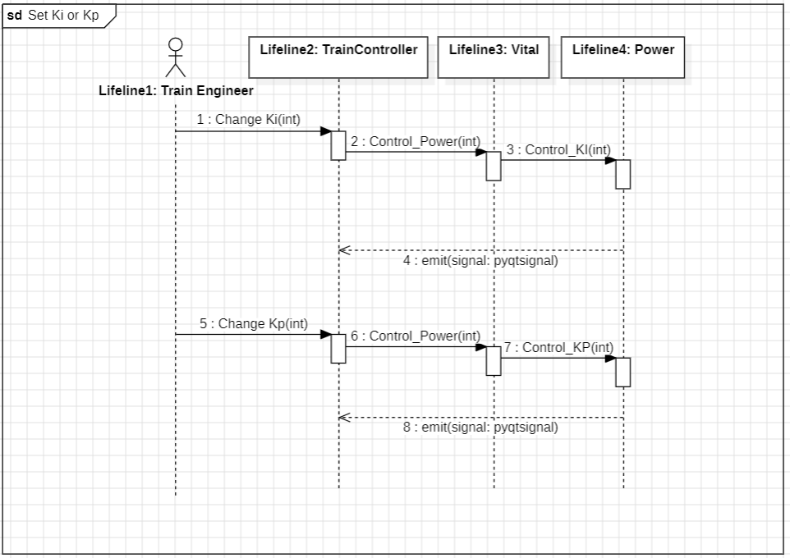

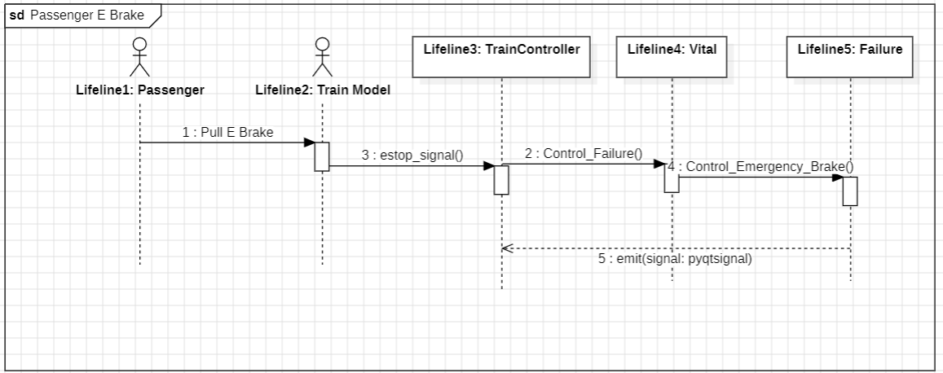

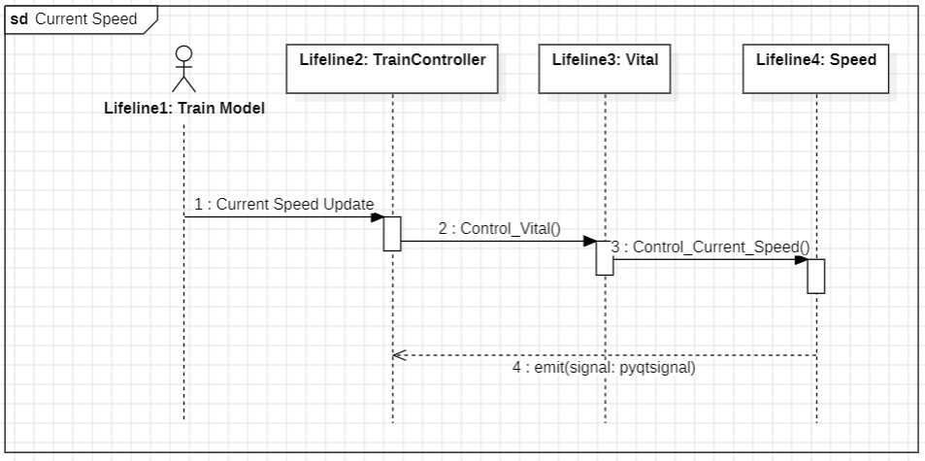

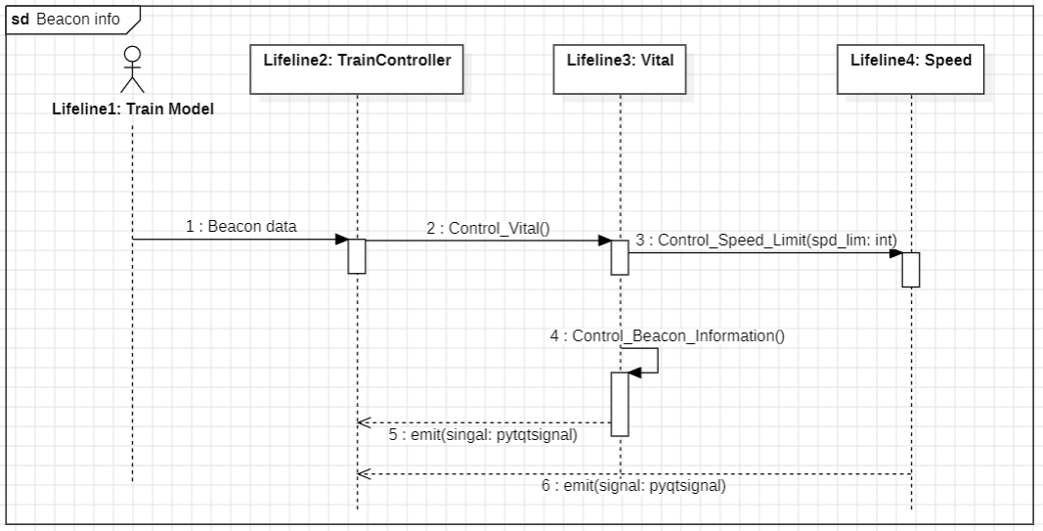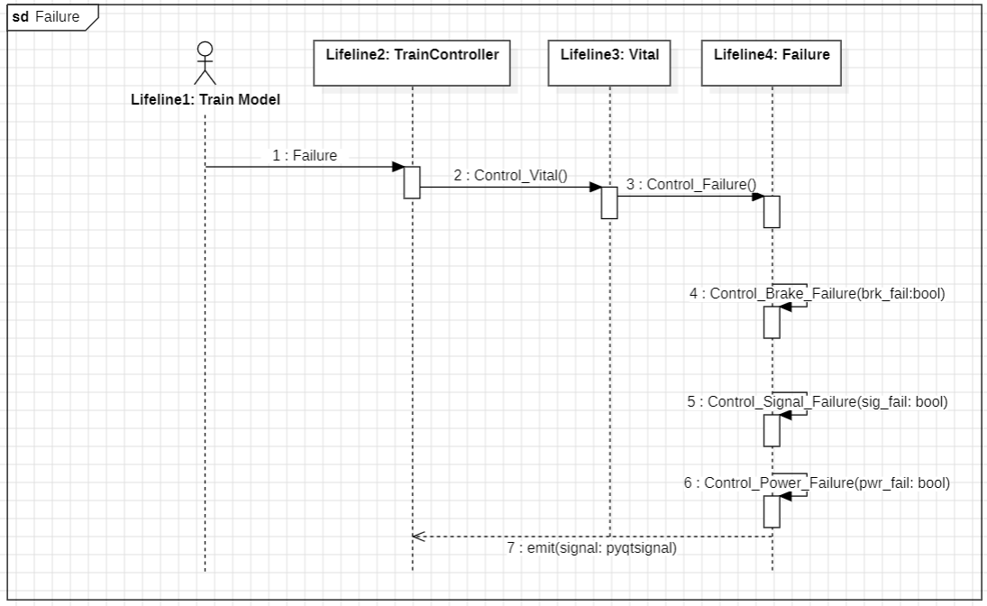

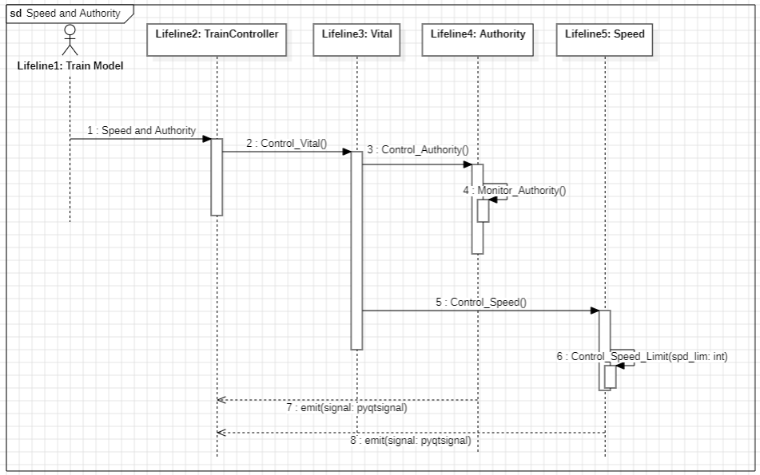

## 5.9 State Dynamics Viewpoint

In order to create real time response within our system, we are utilizing the PyQT Signals Class. This class allows us to create signal-slot functions, where when a signal is emitted, it automatically calls a function it is tied to. This facilitates modules to pass along values and call functions without other modules without the use of API’s.

### 5.9.1 CTC

The CTC module receives inputs from the dispatcher user, wayside controllers, and track model. It also reacts to an internal clock to synchronize the schedule with its outputs to other modules.

| **CTC Output Signals** | |
| --- | --- |
| **Signal Name** | **Signal Output** |
| sendDispatchInfo(list[str, str, int, int]) | To Wayside: A list in the format of line, train ID, suggested speed and authority. Will be sent out any time a train needs dispatched according to the schedule and the clock |
| sendBlockClosures(list[str]) | To Wayside: a list of the current block closures the dispatcher sets in maintenance mode, will send anytime the dispatcher closes or reopens a block. |
| sendSwitchPositions(list[str,str]) | To Wayside: a list of the current switch positions the dispatcher sets in maintenance mode |

### 5.9.2 Wayside Controller

#### 5.9.2.1 Software

| **Wayside (Software) - Output Signals** | |
| --- | --- |
| **Signal Name** | **Signal Output** |
| sendSpecialBlocks(list[Block]) | To Track Model: Sending list of blocks that contain changes to lights, switches, and/or crossings |
| sendAuthority(int) | To Track Model: Sending authority that originally comes from CTC that may or may not have been altered by Wayside. |
| sendCommandedSpeed(int) | To Track Model: Sending commanded speed that originally comes from CTC. It will be the same as the speed sent from CTC unless we need to stop. If we need to stop, we will just send a 0. |
| OccBlocksChanged(list[Block]) | To CTC: Sending the list of all blocks with blocks that have an occupancy change updated with correct attributes. |

#### 5.9.2.1 Hardware

| **Wayside (Hardware) - Output Signals** | |
| --- | --- |
| **Signal Name** | **Signal Output** |
| blockStates(list[Block]) | To Track Model: Sending list of blocks that contain changes to lights, switches, and/or crossings |
| sendAuthority(int) | To Track Model: Sending authority that originally comes from CTC that may or may not have been altered by Wayside. |
| sendCommandedSpeed(int) | To Track Model: Sending commanded speed that originally comes from CTC. It will be the same as the speed sent from CTC unless we need to stop. If we need to stop, we will just send a 0. |
| occBlocksChanged(list[Block]) | To CTC office: Sending the list of all blocks with blocks that have an occupancy change updated with correct attributes. |

### 5.9.3 Track Model

The Track Model module receives inputs from the user Murphy, Track Builder, and the Wayside Controller.

| **Track Model - Output Signals** | |
| --- | --- |
| **Signal Name** | **Signal Output** |
| send_commandedSpeed(int) | To Train Model: Sending commanded speed that originally comes from CTC. It will be the same as the speed sent from CTC unless we need to stop. If we need to stop, we will just send a 0. |
| send_Authority(int) | To Train Model: Sending authority that originally comes from CTC that may or may not have been altered by Wayside. |
| send_occupancies(list[Block]) | To Wayside Controller: Sending a list of occupied blocks. |
| send_tickets(int) | To CTC: Sending the number of ticket sales to CTC every hour at every station. |

### 5.9.4 Train Model

| **Train Model - Output Signals** | |
| --- | --- |
| **Signal Name** | **Signal Output** |
| authority_output_signal(float) | To Train Controller: Sending authority signal that Train model receives from track model |
| beacon_output_signal() | To Train Controller: Sending beacon signal that Train Model receives from track model |
| acc_velocity_signal() | To Train Controller: Sending calculated actual velocity to Train Controller |
| brake_fail_signal() | To Train Controller: Updating Train Controller about Murphy related failures |
| engine_fail_signal() | To Train Controller: Updating Train Controller about Murphy related failures |
| sig_pick_fail_signal() | To Train Controller: Updating Train Controller about Murphy related failures |
| estop_signal() | To Train Controller: Informing Train Controller if a passenger pulls the emergency stop |
| send_commanded_speed_signal() | To Train Controller: Sending commanded speed to Train Controller |
| send_underground_signal() | To Train Controller: Sending upcoming underground status to Train Controller |
| send_deboarding_passengers_signal() | To Track Model: Updating Track Model regarding the number of passengers getting off at a station. |

### 5.9.5 Train Controller

| **Train Controller Output Signals** | |
| --- | --- |
| **Signal Name** | **Signal Output** |
| curr_power_sig(int) | To Train Controller, the current power value in Watts |
| service_brake_sig(bool) | To Train Controller, enabling or disabling the service brake |
| door_control_sig(int) | To Train Controller, an 2 bit integer representing the door state where bit 1 is the left door and bit 2 is the right door  00 (0) - both doors closed  01 (1) - left door open, right door closed  10 (2) - left door closed, right door open  11 (3) - both doors opened |
| announcement_sig(string) | To Train Controller, a string representing the desired speaker outputs |
| temp_control_sig(int) | To Train Controller, a new temperature to set the air conditioning system too |

## 5.10 Resource Viewpoint

A Raspberry Pi Model 4 B is used within the train controller and wayside units performing vital system calculations. The Raspberry Pi controllers are integrated into the system using serial communication via USB.